Queen Reference Guide
Notes:
- Red background indicates a photo from a photocopy scan (Showcase 50th Anniversary book, Newspaper clippings in Showcase collection etc.) that should be replaced if possible.
- Yellow background indicates no photo found so far.
- If any photos are added from another source (i.e. Florida Memory, newspaper, magazine, etc.), please indicate the source below the thumbnail. This includes FSC sources such as the Interlachen and The Southern as they are considered “outside sources” for this project.

Year | Queen | Biography Progress and Writer? | Thumbnail Image
1924 | Dorothy Williamson | ✅  Lauren | 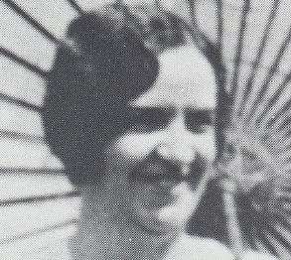
1930 | Ruth Snyder | 🚧  Emily | 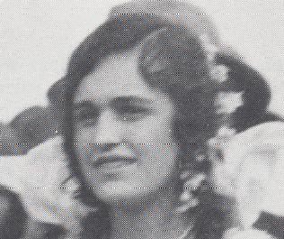
1931 | Bertha Knight | 🚧  Emily | 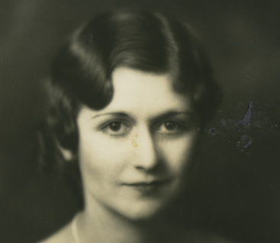
1932 | Kathleen Kelley | 🚧  Emily | 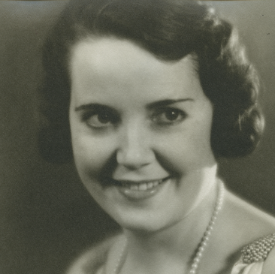
1933 | Mary Louise Moore | 🚧  Emily | 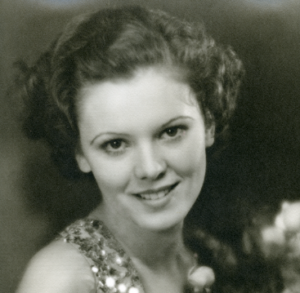
1934 | Marjorie Giddens | 🚧  Emily | 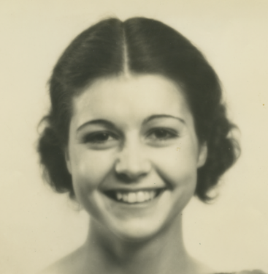
1935 | Betty Runkle | 🚧  Emily | 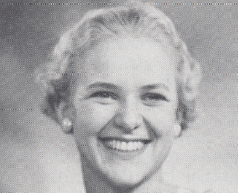
1936 | Beatrice “Bea/Bee” Huyck | 🚧  Emily | 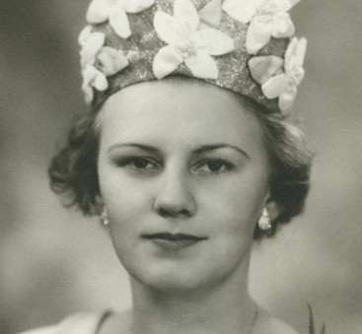
1937 | Doris Harrison | 🚧  Emily | 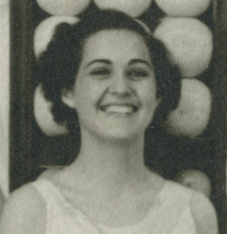
1938 | Beth Page | 🚧  Emily | 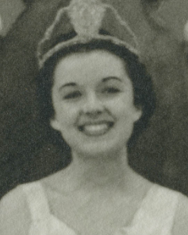
1939 | Mary Frances Copps | 🚧  Emily | 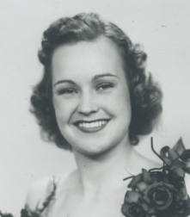
1940 | Leone Johnson | 🚧  Emily | 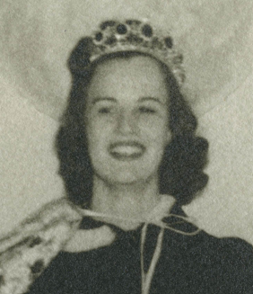
1941 | Christine Elizabeth Colson | 🚧  Emily | 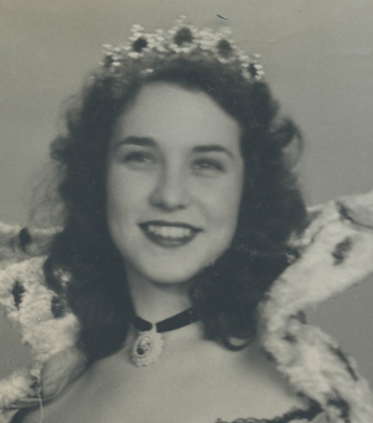
1942 | Juanita Iveane Hall | 🚧  Emily | 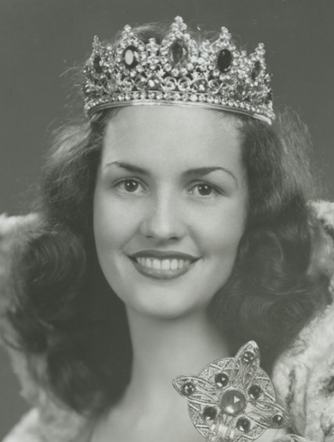
1943 | Gloria Lansden | ✅  Lauren | 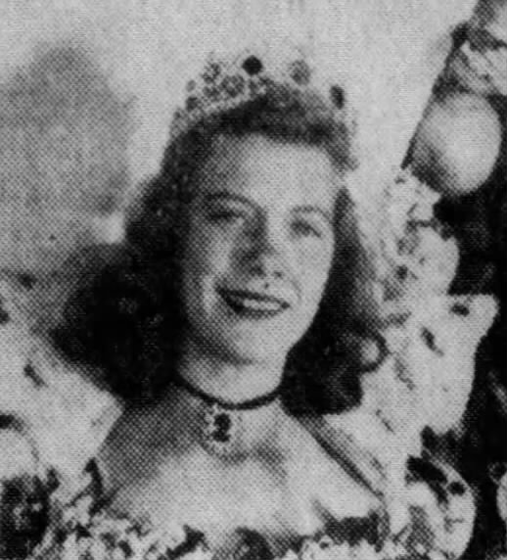  Newspapers.com
1943 | Sylvia Chambliss | ✅  Lauren | 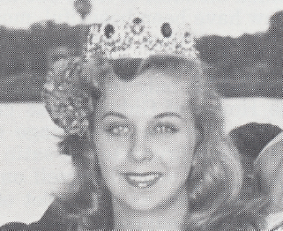
1944 | Iris Abel | ✅  Lauren | 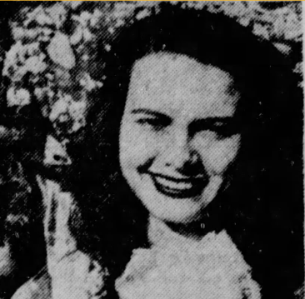  Newspapers.com
1945 | Laurel Norden | ✅  Lauren | 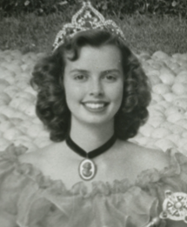
1946 | Selma Rocker | ✅  Lauren | 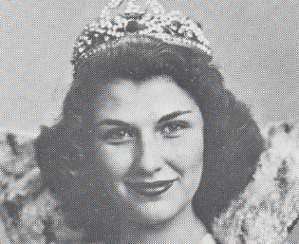
1947 | Nance Stilley | ✅  Lauren | 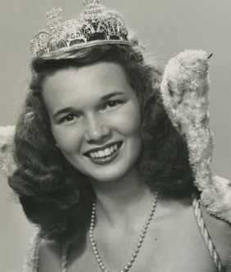
1948 | Shirley Rhodes | ✅  Lauren | 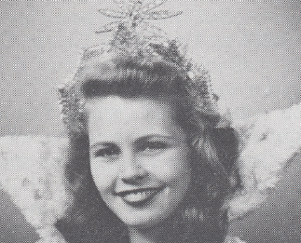
1949 | Joan Cook | ✅  Lauren | 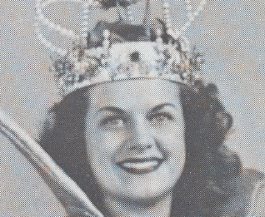
1950 | Kathy Darlyn | ✅  Lauren | 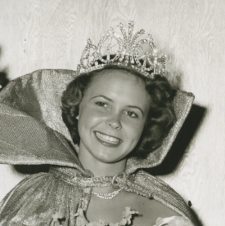
1951 | Carolyn Stroupe | ✅  Lauren | 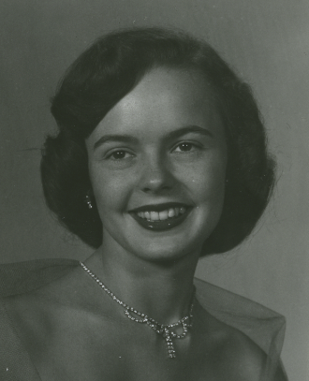
1952 | Pat Burgoon | ✅  Lauren | 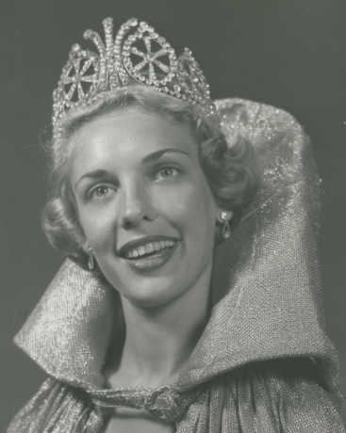
1953 | Marion Ettie | ✅  Lauren | 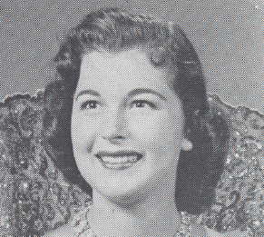
1954 | Ann Daniel | ✅  Lauren | 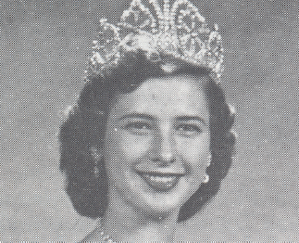
1955 | Sally Ardrey | ✅  Lauren | 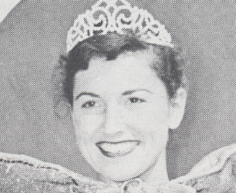
1956 | Dorothy Steiner | ✅  Lauren | 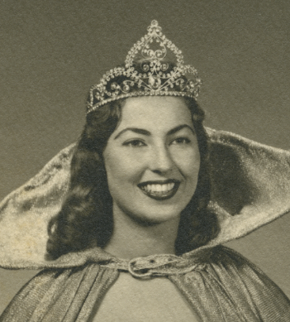
1957* | Frances Layton | ✅  Lauren | 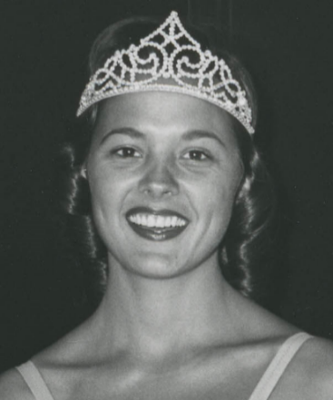
1957* | Carol Baldwin | ✅  Lauren | 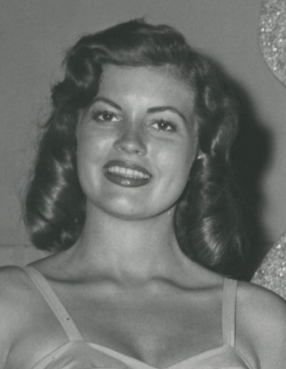
1958 | Kay MacLean | ✅  Lauren | 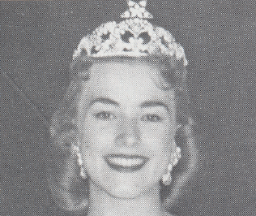
1959 | Sandra Freeman | ✅  Lauren | 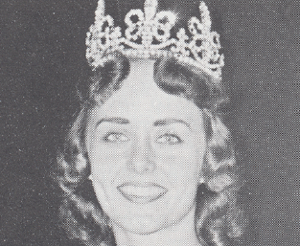
1960 | Florence Cloud | ✅  Lauren | 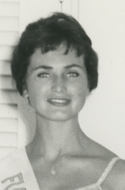
1961 | Sandra Guthrie | ✅  Lauren | 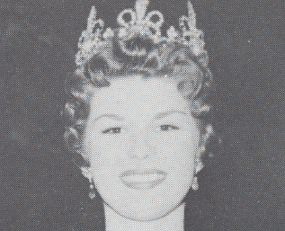
1962 | Sharon Conrad | ✅  Lauren | 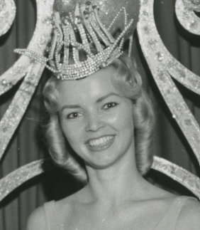
1963 | Brenda Sue Scarbrough | ✅  Lauren | 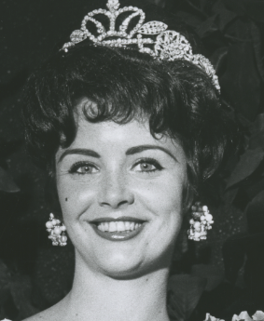
1964 | Nancy Collins | ✅  Lauren | 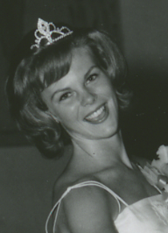
1965 | Karol Kelly | ✅  Lauren | 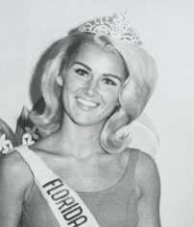
1966 | Lavoyce Leggett | ✅  Lauren | 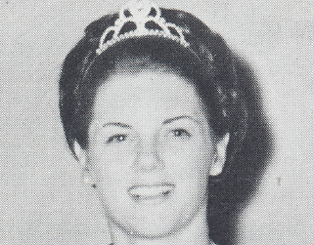
1967 | Patti Bohannon | ✅  Lauren | 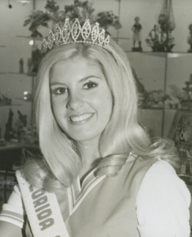
1968 | Lynne Allen | ✅  Lauren | 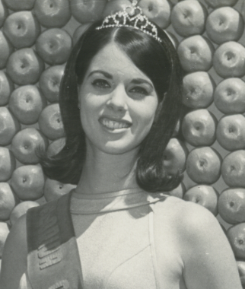
1969 | Kathy Young | ✅  Lauren | 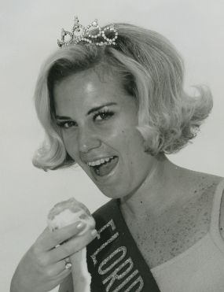
1970 | Suzanne Rogers | ✅  Lauren | 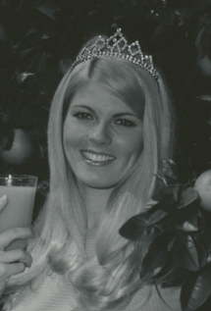
1971 | Sue Comer | ✅  Lauren | 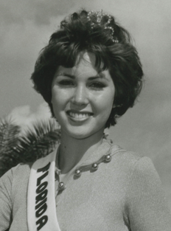
1972 | Christine Couldron | ✅  Lauren | 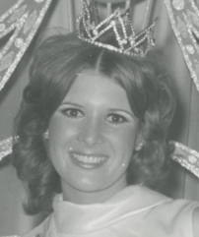
1973 | Wanda Lynn Miller | ✅  Lauren | 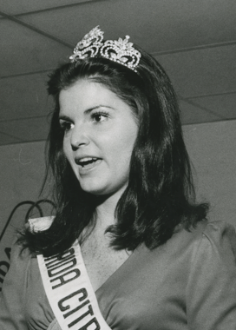
1974* | Terry Ann Browning | ✅  Lauren | 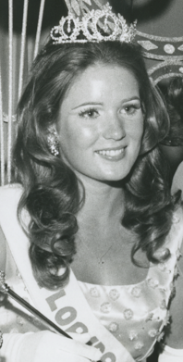
1974* | Debi Adair | ✅  Lauren | 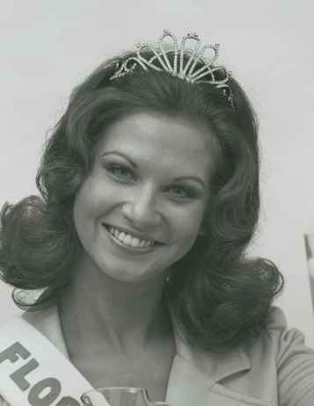
1975 | Sonya Surrency | ✅  Lauren | 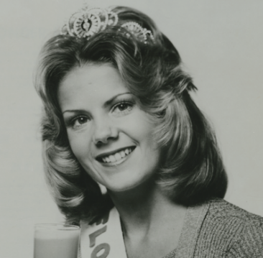
1976 | Candace Upthegrove | ✅  Lauren | 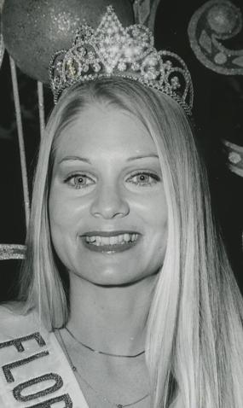
1977 | Lisa Maile | ✅  Lauren | 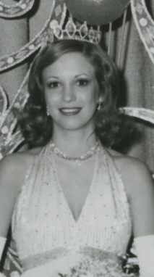
1978 | Lisa Lyon | ✅  Lauren | 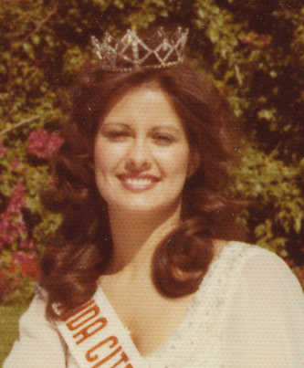
1979 | Nancy Ness | ✅  Lauren | 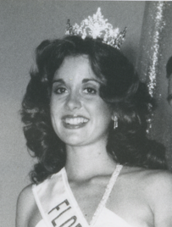
1980 | Theresa Mahoney | ✅  Lauren | 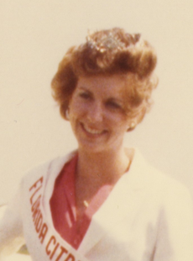
1981 | Brenda Eubanks | ✅  Lauren | 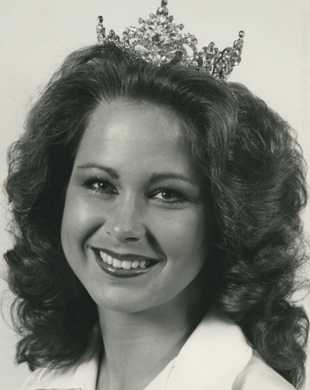
1982 | Dawn Griffin | ✅  Lauren | 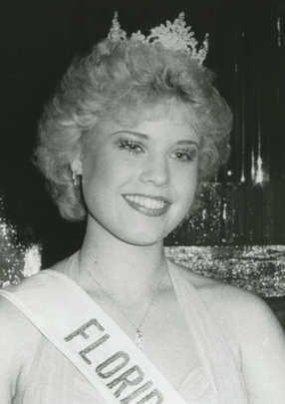
1983 | Deidre Perkins | ✅  Lauren | 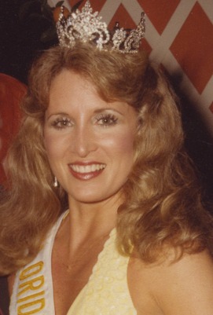
1984 | Lori Schirard | ✅  Lauren | 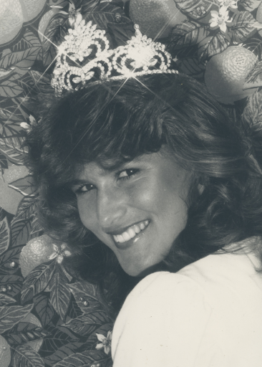
1985 | Vicki Lynne Carver | ✅  Lauren
1986 | Rosemarie Payne | ✅  Lauren | 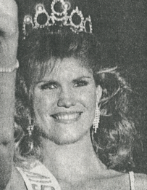
1987 | Renee McLeod | ✅  Lauren
1988 | Judy Berretto | ✅  Lauren | 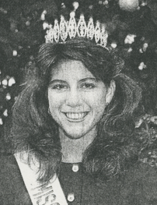
1989 | Sherri Hensley | ✅  Lauren | 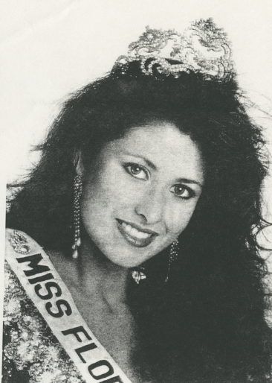
1990 | Laura Benefield | ✅  Lauren | 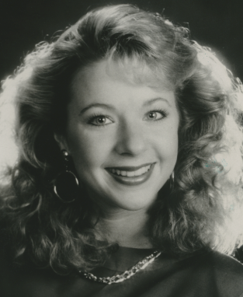
1991 | Mandy Hancock | ✅  Lauren
1992 | Sheri Cook | ✅  Lauren | 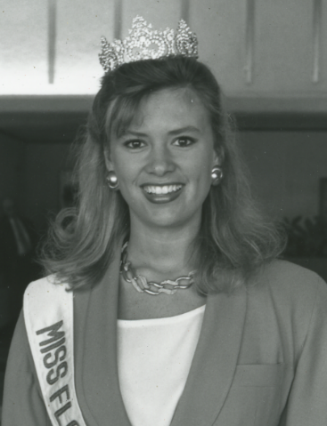
1993 | Emily Howell | ✅  Lauren | 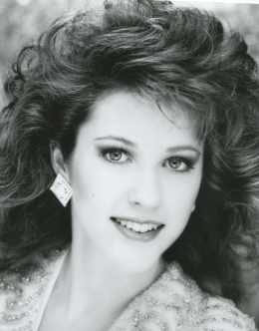
1994 | Tobitha Bryant | ✅  Lauren
1995 | Dana Morgan | ✅  Lauren | 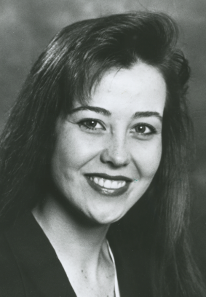
1996 | Becka Cerni | ✅  Lauren | 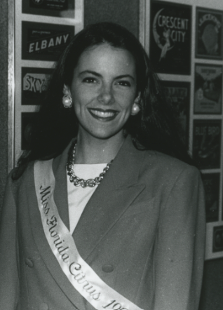
1997 | Shannon Potts | ✅  Lauren
1998 | Candace “Candy” Griffin | ✅  Lauren | 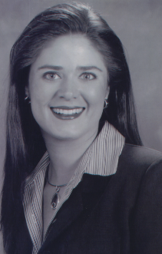
1999 | Kim Duppenthaler | ✅  Lauren
2000 | Kimber Wood | ✅  Lauren
2001 | Jennifer Peavey | ✅  Lauren
2002 | Morgan Ortagus | ✅  Lauren
2004 | Erin Nichole "Nikki" Upthegrove | ✅  Lauren
2015 | Summer Foley | ✅  Lauren
2016 | Stephanie Capon | ✅  Lauren
2017* | Paige Todd | ✅  Lauren
2017* | Rachel Smith | ✅  Lauren
2018 | Megan Price | ✅  Lauren
2019* | Michaela McLean | ✅  Lauren
2019* | Juliana Fray | ✅  Lauren
2020-2021 | Leila Sabat | ✅  Lauren
2022 | Payton Barrington | ✅  Lauren
2023 | Casana Fink | ✅  Lauren

*In 1957, 1974, 2017 and 2019, the first Queen listed resigned her position. Frances Layton resigned to get married. Terry Browning resigned as she won Miss World USA 1974. Paige Todd resigned to focus on her studies. Michaela McLean resigned as she won Miss Florida 2019 and was busy in that role and competing in Miss America 2020.

Notes for Writing Biographies:
- Please make sure all articles have been clipped on Newspapers.com. If you want to go ahead and create screenshots/pdfs of other articles, that would be greatly appreciated 😊. This way we have a backup in case there are any database issues.
- While it seems dated, “homemaker” appears to be the best term to describe any of the Queens who were not employed and who managed the home. “Homemaker” is more individual-based term rather than a term that bases her identity relative to her spouse (“housewife”) or child (“stay-at-home-mother”). It also apparently was undergoing a reclamation in 2013 as a gender-neutral term that also was expanding on the meaning of what it takes to manage a home.

Biographies
Queen | Bio
✅Dorothy Williamson 1924 | Dorothy Williamson was born on March 8, 1902, in Winter Haven, Florida. She was the daughter of Francis E. Williamson, owner of Winter Haven’s Ritz Theater. Dorothy was 22 years old when she was crowned as the first Citrus Queen in 1924, alongside the one and only Citrus King, Harvey Henderson. The citrus rulers were chosen by ballot and voted on by the people of Polk County. After her reign, Dorothy was the President of Winter Haven’s Business and Professional Women’s Club. She passed away on August 2, 1943.  Sources  Burr, Josephine. History of Winter Haven Florida. Larry Burr Printing Company, 1974. https://www.egovlink.com/public_documents300/winterhaven/published_documents/Winter%20Haven/Library/History_of_Winter_Haven.pdf.  “Dorothy Williamson (1902-1943).” Find a Grave. Ancestry.com, April 16, 2011. https://www.findagrave.com/memorial/68453153/dorothy-williamson.
✅Ruth Snyder 1930 | Ruth Snyder was born on August 27, 1910 in New Jersey. She attended and graduated from Lakeland High School. Ruth was 19 when she won the crown of Florida Citrus Queen in 1930. Towards the end of her reign, in October 1930, Ruth got married to her first husband Kenneth King. After her reign, Ruth went on to New York and became an actress and homemaker. Years later, she moved to Houston and married her second husband Richard Onarecker. She later passed away on July 20, 1971.  Sources  “Clois W. Snyder.” The Tampa Tribune (Tampa, Florida), January 30, 1962.  “First Citrus Queen.” The Tampa Tribune (Tampa, Florida), March 10, 1964.  “Former Residents of Lakeland Wed in New York City.” The Tampa Tribune (Tampa, Florida), October 13, 1930.  “Ruth Cooper Snyder (1910-1971).” FamilySearch, accessed August 16, 2023. https://ancestors.familysearch.org/en/GW2V-YBX/ruth-cooper-snyder-1910-1971.  “Ruth Snyder Onarecker (1910-1971).” Find a Grave. Ancestry.com, September 14, 2015. https://www.findagrave.com/memorial/152315446/ruth-onarecker.
✅Bertha Knight 1931 | Bertha Knight was born on July 15, 1912 in Bartow, Florida. Bertha was 19 when she won the crown of Florida Citrus Queen in 1931. Her father Edgar Wilson Knight was a federal state plant inspector exposing her to the citrus industry from a young age. Bertha’s sponsor during the competition was the Bartow Chamber of Commerce. During her reign as queen, she got married to her first husband Hubert Myers in 1931. Bertha would later marry her second husband Rev. E. Lawrence Bottinger in 1976. After her reign, became an interior designer and opened her own restaurant. She passed away on November 27, 2006.  Sources  “Bertha Knight Bottiger (1912-2006).” Find a Grave. Ancestry.com, November 28, 2006. https://www.findagrave.com/memorial/16816876/bertha-bottiger.  “Judges Pick Bartow Girl to be Queen of Orange Festival.” The Tampa Tribune (Tampa, Florida), January 21, 1931.  “Miss Bertha Knight, Orange Fete Queen, Married at Bartow.” The Tampa Tribune (Tampa, Florida), March 26, 1931.
🎞️❗Kathleen Kelley 1932 | Kathleen Kelley was born on May 5, 1908 in Pinellas County, Florida. She was 23 when she won the crown of Florida Citrus Queen in 1932. Her sponsor for the pageant was the Kiwanis Club of Lakeland. Post reign Kathleen would marry Arthur Raymond Hanson in 1934 and later would move to North Carolina where she was a homemaker. She passed away on November 5, 1980.  Sources  “Kathleen Kelley Hanson (1908-1980).” Find a Grave. Ancestry.com, July 19, 2013. https://www.findagrave.com/memorial/114046891/kathleen-hanson.  “Kathleen Odom Kelley (1908-1980).” FamilySearch, accessed July 21, 2023. https://ancestors.familysearch.org/en/GMZ5-D3K/kathleen-odom-kelley-1908-1980.  “Western North Carolina Deaths, Funerals.” The Asheville Times (Asheville, North Carolina), November 7, 1980.  Ledger - microfilm
✅Mary Lou Moore 1933 | Mary Louise Moore was born on September 11, 1916 in Clearwater, Florida. She was only 16 when she won the crown of Florida Citrus Queen in 1933. Mary received her high school diploma post-reign as queen. She then went on to marry her husband Kelsie Loomis Reaves in 1937. She would move multiple times with her husband first for her career as a Radio Talent to New York City and later for his military career to the Philippines where he was stationed. Mary passed away on December 15, 1997.  Sources  “Mary Louise Reaves (1916-1997).” Find a Grave. Ancestry.com, February 15, 2015. https://www.findagrave.com/memorial/142597141/mary-louise-reaves  “Queen Crowned at Opening of Orange Fete.” The Tampa Tribune (Tampa, Florida), January 25, 1933.  “Miss Mary Lou Moore Lt. Reaves Will Wed Tonight at Fort Screven, GA.” The Tampa Times (Tampa, Florida), October 23, 1937.  “Mary Lou Moore Signs with Radio Stations.” Tallahassee Democrat (Tallahassee, Florida), March 6, 1936.
✅Marjorie Giddens 1934 | Marjorie Giddens was born on March 1, 1917 in Lakeland, Florida. She was 17 when she won the crown of Florida Citrus Queen in 1934. Marjorie attended and graduated from Lakeland High School. Her sponsor during the competition was the Lakeland Rotary Club. Marjorie would later marry her husband the Honorable William A Macomber, Jr. and move west to San Diego, California, and later Nevada. She passed away on December 22, 1990.  Sources  “Debbie Verdieck to be Bride of F. Jefferey Macomber.” Redlands Daily Facts (Redlands, California), May 5, 1976.  “Giddens.” Independent (Long Beach, California), June 13, 1963.  “Orange Fete Queen Named.” The Tampa Times (Tampa, Florida), January 17, 1934.  “Marjorie Giddens.” FamilySearch.com, accessed July 21, 2023. https://www.familysearch.org/tree/person/details/G798-JYT.  “Named Queen of Oranges.” Henderson Daily Dispatch (Henderson, North Carolina), January 23, 1934  “Stewart-Giddens Nuptial Vows Taken in Formal Rites Saturday.” The Pomona Progress Bulletin (Pomona, California), June 24, 1946.  “Vista Court Judge Dead.” Times-Advocate (Escondido, California), May 3, 1973.
✅Betty Runkle 1935 | Betty Runkle was born on June 4, 1914 in Sunbury, Pennsylvania. She was 20 when she won the crown of Florida Citrus Queen in 1935. Betty attended and graduated from Winter Haven High School. Post-reign, Betty would stay in Florida and work as a volunteer at Cypress Gardens. She also would go on to marry her first husband Harlan Jameson in 1940 and then would later marry her second husband Leroy Sutton. She passed away on April 5,2002.  Sources  Ellis, Billie. “Woman Has 60 Year History With Gardens.” The Ledger (Lakeland, Florida), September 29, 1996.  “Elizabeth F. ‘Betty’ Runkle Jameson Sutton (1914-2002).” Find a Grave. Ancestry.com, February 11, 2015. https://www.findagrave.com/memorial/142478221/elizabeth-f-jameson_sutton.  “Queen of the Florida Orange Festival.” The Tampa Times (Tampa, Florida), January 22, 1935.
✅Beatrice “Bee/Bea” Huyck 1936 | Beatrice “Bee” Huyck was born on September 17,1914 in Batavia, New York. She was 22 when she won the Crown of Florida Citrus Queen in 1936. She attended the American School of Chicago where she received her diploma. During the pageant, she was sponsored by the Haines City Chamber of Commerce. Post-reign, she would marry her husband John Friesner, Jr. in 1937. Bee would also go on to become a volunteer “pink lady” at Winter Haven Hospital, a member of the Winter Haven Garden Club, and a member of the Order of the Eastern Star. She passed away on January 31, 2012.  Sources  “Beatrice Lucy Huyck Friesner (1914-2012).” FamilySearch, accessed July 21, 2023. https://www.familysearch.org/ark:/61903/1:1:QVLF-7BFY.  “Beatrice Lucy Huyck Friesner (1914-2012).” Find a Grave. Ancestry.com, September 18, 2012. https://www.findagrave.com/memorial/97336085/beatrice-lucy-friesner.  “Friesner-Huyck.” The Orlando Sentinel (Orlando, Florida), February 20, 1937.  “Orange Queen.” The Tampa Tribune (Tampa, Florida), January 28, 1936.  “‘36 Orange Queen Wed at Palataka.” Miami Tribune (Miami, Florida), February 18, 1937.
✅Doris Harrison 1937 | Doris Harrison was born on February 19,1920 in Bartow, Florida. She was just 16 when she won the crown for Florida Citrus Queen in 1937. Doris was sponsored by the American Legion during the competition. She would also win the American Legion Beauty Pageant in 1937. After her reign, Doris would go on to become a job advisor for the state. She passed away on March 19,1997.  Sources  “Doris R. Harrison.” The Tampa Tribune (Tampa, Florida), March 21, 1997.  “Doris Ramelle Harrison (1920-1997).” FamilySearch, accessed July 21, 2023. https://www.familysearch.org/tree/person/details/MSVR-37F.  “Miss Bartow.” The Tampa Tribune (Tampa, Florida), December 27, 1936.  “Orange Queen.” News-Press (Fort Myers, Florida), January 22, 1937.
✅ (Pearl) Elizabeth “Beth” Page 1938 | Pearl Elizabeth “Beth” Page was born in 1920 in Bartow, Florida. She was 17 when she won the crown of Florida Citrus Queen in 1938. She held a connection to the citrus industry through her uncle Claud Page and was a member of one of the first families of Bartow. She attended and graduated from Bartow High School. Beth was also the winner of the American Legion Beauty Contest, as well as the Garden Festival Queen of 1939. Later, she would marry her husband Wilbur A. Steen Jr. in 1945. The exact date of when Beth passed away is unknown.  Sources  “Bartow Girl Named Orange Festival Queen.” The Tampa Tribune (Tampa, Florida), January 18, 1938.  “Beth Page Steen (1920-unknown).” Find a Grave. Ancestry.com, January 22, 2008. https://www.findagrave.com/memorial/24109401/beth-page-steen.  “Claude Page.” The Tampa Tribune (Tampa, Florida), January 27, 1963.  “Crowned Queen.” St. Lucie News Tribune (Fort Pierce, Florida), April 13, 1939.  “Miss Pearl Page of Bartow is Bride of Wilbur A. Steen, Jr.” The Tampa Tribune (Tampa, Florida), January 21, 1945.  Pearl Elizabeth Page and Wilbur Steen, marriage license, January 20, 1945, file no. 1945912902, Polk County Clerk of Courts, https://apps.polkcountyclerk.net/browserviewor/.  “Will Reign as Festival Queen.” The Tampa Times (Tampa, Florida), January 18, 1938.
✅Mary Frances Copps 1939 | Mary Copps was born on September 29, 1921 in Tampa, Florida. She was 17 when she won the crown of Florida Citrus Queen in 1939. Mary was sponsored by the Tampa Terrace Hotel. She attended and graduated from Plant High School. During her reign as queen, she married her husband Gabriel “Gabe” Paul in 1939. Mary later moved to New York and Cincinnati and became a model and homemaker. She passed away on June 21, 2015.  Sources  “Mary Frances Paul.” The Plain Dealer (Cleveland, Ohio), July 26, 2015. https://obits.cleveland.com/us/obituaries/cleveland/name/mary-paul-obituary?id=20365152.  “News of Social and Club Events in Tampa and Vicinity.” The Tampa Times (Tampa, Florida), April 18, 1939.  “Tampa Girl, 17, Queen of Fete.” The Tampa Times (Tampa, Florida), January 24, 1939.  “Vicki Vies for Place Among Long List of Citrus Royalty.” St. Lucie News Tribune (Fort Pierce, Florida), February 5, 1974.
✅(Evelyn) Leone Johnson 1940 | Leone Johnson was born in 1920 in Plant City, Florida. She was 20 when she won the crown for Florida Citrus Queen in 1940. She was sponsored by the Haines City Booster Club during the competition. During her reign, she married her husband Richard T. Brown in August 1940. She went on to become a homemaker and stayed in Florida. She passed away on April 28, 2007.  Sources  “Brown, Leone.” The Orlando Sentinel (Orlando, Florida), May 1, 2007. https://www.legacy.com/us/obituaries/orlandosentinel/name/leone-brown-obituary?id=25141876.  “Evelyn Leone Johnson Brown (1919-2007).” Find a Grave. Ancestry.com, July 19, 2010. https://www.findagrave.com/memorial/55158887/evelyn-leone-brown.  “Leone Johnson is Queen of Festival at Haven.” The Orlando Sentinel (Orlando, Florida) January 23, 1940.  “Miss Johnson and Richard Brown are Married at Orlando.” The Tampa Tribune (Tampa, Florida), September 1, 1940.  “Vicki Vies for Place Among Long List of Citrus Royalty.” St. Lucie News Tribune (Fort Pierce, Florida), February 5, 1974.
✅Elizabeth Colson 1941 | Elizabeth Colson was born around 1925 in Leesburg, Florida. She was 16 when she won the crown of Florida Citrus Queen in 1941. She attended and graduated from Leesburg High School. During the competition, the Kiwanis Club sponsored her. Post-reign, she won Most Photogenic Girl in Florida in 1942. Elisabeth later married her husband James R. Golden in 1943. She later moved to Atlanta, Georgia and Washington D.C. where she became a high fashion model. As of writing, it is unknown if she has passed away.  Sources  “Leesburg Girl Selected New Queen of Orange Festival at W. Haven.” The Tampa Times (Tampa, Florida), January 28, 1941.  “Golden, James R.” The Orlando Sentinel (Orlando, Florida), December 21, 2011. https://www.legacy.com/us/obituaries/orlandosentinel/name/james-golden-obituary?id=19841929.  “Miss Christine Colson and Lieutenant Golden Married at Leesburg.” The Tampa Tribune (Tampa, Florida), October 10, 1943.  “Photogenic.” The Tampa Bay Times (St. Petersburg, Florida), June 12, 1942.
✅(Juanita) Iveane Hall 1942 | Juanita Iveane Hall was born in August 1923 in Los Angeles, California. She was 18 when she won the crown of Florida Citrus Queen in 1942. She attended and graduated from Lakeland High School. She was sponsored by the Lakeland Junior Chamber of Commerce during the competition. After winning Florida Citrus Queen, Iveane went on to win Miss Florida. She had previously won Miss Lakeland and Miss Florida Glamor Girl in 1941, and later Azalea Queen. Post-reign, she married Harold Scruggs in 1943, whom she moved with to Phoenix, Arizona and to Panama as part of his military career. Iveane passed away on August 15, 2000.  Sources  “Boys in Uniform Salute Average Girl Symbolized by Beauty Winner.” The Philadelphia Inquirer (Philadelphia, Pennsylvania), April 19, 1942.  “Col. Harold Woodward Scruggs (1916-2007).” Find a Grave. Ancestry.com, November 21, 2007. https://www.findagrave.com/memorial/23016486/harold-woodward-scruggs.  “Orange Festival Queen is Crowned.” The Tampa Times (Tampa, Florida), January 22, 1942.  “Citrus Exposition to Add New Queen.” The Tampa Times (Tampa, Florida), February 10, 1951.  “Glamor Girls - In Fur!” The Key West Citizen (Key West, Florida), July 10, 1941.  “Juanita Iveanne Hall Scruggs (1923-2000).” Find a Grave. Ancestry.com, April 28, 2009. https://www.findagrave.com/memorial/36516645/juanita-iveane-scruggs.  “Lakeland Beauty Crowned ‘Azalea Queen’ at Palatka.” The Tampa Times (Tampa, Florida), March 2, 1945.  “Scruggs-Hall.” Tallahassee Democrat (Tallahassee, Florida), September 5, 1943.
✅Gloria Lansden 1943 | Gloria Lansden was born on January 8, 1926 in Winter Haven, Florida. She graduated from Winter Haven High School. Gloria was 17 years old when she was crowned Florida Citrus Queen. After her reign, she attended the Protestant School of Nursing in Nashville, Tennessee and Peabody College. Eventually she moved to Akron, Ohio, where she worked as a nurse. Gloria married Paul Herman on February 4, 1953. Gloria passed away on October 6, 1996.  Sources  “Dr. Frank T. Lansden.” Hendersonville Times-News (Hendersonville, North Carolina). September 6, 2012.  “Gloria Lansden (Deceased).” FamilySearch, accessed August 16, 2023. https://ancestors.familysearch.org/en/GF8M-SCD/gloria-lansden-.  “Marriage Announced.” The Orlando Sentinel (Orlando, Florida), February 27, 1953.  “Miss Gloria Lansden Crowned Orange Queen.” The Orlando Sentinel (Orlando, Florida), February 9, 1943.  [Photograph of Gloria Lansden, Tangerine Queen]. The Dayton Herald (Dayton, Ohio), December 26, 1943.  “Soldiers Eat Throne of Citrus Queen.” The Miami Herald (Miami, Florida), February 9, 1943.
✅Sylvia Chambliss 1943 | Sylvia Chambliss was born in 1923 in Knoxville, Tennessee. She was 20 years old when she was crowned Florida Citrus Queen in 1943. This was in a special wartime ceremony to persuade the public to purchase war bonds. Prior to the Florida Citrus Queen contest, Sylvia was a water skier at Cypress Gardens. After her reign, she moved to New York City where she was a model. Sylvia married John McElvey on September 7, 1944 and eventually moved to Middleburg, Virginia where she farmed horses. As of writing, it is unknown if she has passed away.  Sources  “Chamblisses Backed Park from the Start.” The Ledger (Lakeland, Florida), January 18, 2006. https://www.theledger.com/story/news/2006/01/19/chamblisses-backed-park-from-the-start/26679249007/.  Dinocola, David. "Selling Sunshine: How Cypress Gardens Defined Florida, 1935-2004." Master’s thesis, University of Central Florida, 2009. Electronic Theses and Dissertations, 2004-2019. 4081. https://stars.library.ucf.edu/etd/4081.  “Miss Chambliss Weds at Winter Haven.” The Tampa Tribune (Tampa, Florida), September 17, 1944.  Sylvia Chambliss and John McElvey, marriage license, September 10, 1944, file no. 1944912344, Polk County Clerk of Courts, https://apps.polkcountyclerk.net/browserviewor/.  “Sylvia Gilchrist.” FamilySearch, accessed August 2, 2023. https://www.familysearch.org/ark:/61903/1:1:KT2Y-SVV.  “Vicki Vies for Place Among Long List of Citrus Royalty.” St. Lucie News Tribune (Fort Pierce, Florida), February 5, 1974.
✅Iris Abel 1944 | Iris Abel was born on June 7, 1924 in Florida. She was 19 when she was crowned Florida Citrus Queen, and her sponsor was the Winter Haven Junior Chamber of Commerce. Her crown was presented by Seaman Robert Crutchfield of the U.S. Navy as the traditional Florida Citrus Exposition was postponed for the year due to World War II. After her reign, Iris moved to San Francisco, California. Iris passed away on January 4, 1983.  Sources  “Festival Queen.” The Herald-Sun (Durham, North Carolina), February 2, 1944.  “Iris U Abel (1924-1983).” FamilySearch, accessed July 17, 2023. https://ancestors.familysearch.org/en/GC4H-5Q5/iris-u-abel-1924-1983.  “Orange Festival Queen.” The Tampa Tribune (Tampa, Florida), January 30, 1944.
✅Laurel White Norden 1945 | Laurel White Norden was born in July 1928 in Winter Haven, Florida. She was 17 years old when she was crowned Florida Citrus Queen. Prior to the Florida Citrus Queen contest, Laurel had been crowned Florida’s Magnolia Queen. After her reign, Laurel completed her bachelor’s degree at Wesleyan College and went on to George Peabody College for Teachers to obtain a master’s degree. She worked as a teacher in Florida. Laurel married Jim Lenfestey on June 28, 1956. She passed away on October 3, 2010.  Sources  “Crowned Queen of Orange Festival.” The Key West Citizen (Key West, Florida), March 9, 1945.  “Laurel White Norden Lenfestley (1928-2010).” Find a Grave. Ancestry.com, January 18, 2012. https://www.findagrave.com/memorial/83673884/laurel-norden_lefestley.  “Lenfestey, Laurel.” The Tampa Tribune (Tampa, Florida), October 5, 2010.  “Magnolia Queen.” The Miami Herald (Miami, Florida), June 25, 1943.
✅Selma Rocker 1946 | Selma Rocker was born on May 3, 1928 in Tampa, Florida. She graduated from Summerlin Institute (now Bartow High School). Selma was 17 years old when she was crowned Florida Citrus Queen, and her sponsor was the Summerlin High School Key Club. After her reign, she became an interior designer and design teacher. Selma married Edwin Ham on July 4, 1948 and later married Claude Segrest. She passed away on May 9, 2016.  Sources  “Rocker-Ham.” The Tampa Tribune (Tampa, Florida), July 14, 1948.  “Selma R. Segrest.” Dignity Memorial. Accessed July 21, 2023. https://www.dignitymemorial.com/en-ca/obituaries/tampa-fl/selma-segrest-6952254.  “Sisters Have Fun as Queen Blushes.” The Tampa Times (Tampa, Florida), February 23, 1946.  “Vicki Vies for Place Among Long List of Citrus Royalty.” St. Lucie News Tribune (Fort Pierce, Florida), February 5, 1974.
✅Nance Stilley 1947 | Nance Stilley was born on December 6, 1928, in Pittsburgh, Pennsylvania. She graduated from Winter Haven High School. Nance was 18 years old when she was crowned Florida Citrus Queen, and her sponsor was the Winter Haven American Legion Post. After her reign, Nance was crowned Bougainvillea Queen later in 1947. She also appeared on the cover of Life Magazine in 1947 before the start of the Florida Citrus Exposition. She later married Dan Hains, and the couple went on to own and operate multiple water ski schools in Wisconsin and New York before returning back to Winter Haven, Florida. Nance passed away on May 6, 2010.  Sources  “Citrus Exposition Crowns Queen.” The Tampa Times (Tampa, Florida), February 19, 1947.  “Flower Queen Title is Taken by ‘Aqua-Maid.’” The Palm Beach Post (West Palm Beach, Florida), March 31, 1947.  “Nance S. Hains.” The Ledger (Lakeland, Florida), May 8, 2010. https://www.legacy.com/us/obituaries/theledger/name/nance-hains-obituary?id=21696262.  “Nance Stilley Citrus Queen.” The Miami Herald (Miami, Florida), February 19, 1947.
✅Shirley Rhodes 1948 | Shirley Rhodes was born on July 1, 1931 in Spartanburg, South Carolina. She graduated from Plant High School. Shirley was 16 years old when she was crowned Florida Citrus Queen, and her sponsor was Florida Frozen Foods Inc. Prior to the Florida Citrus Queen contest, Shirley had been crowned Miss Holiday in 1948. After her reign, she went on to collect the crowns of Miss Tampa and Miss Florida. Shirley married August Dielens on June 30, 1951 and eventually moved to Georgia and South Carolina before returning to Florida. She passed away on December 21, 1979.  Sources  “August J. Dielens, Jr.” USMA Class of 1950, October 7, 2014. https://www.usma1950.com/memorial/august-j-dielens-jr.  “Miss Shirley Rhodes Engaged to Wed Lt. A. J. Dielens Jr.” The Tampa Times (Tampa, Florida), January 16, 1951.  “Luncheons, Teas Precede Lazy Summer Days.” The Tampa Times (Tampa, Florida), May 24, 1958.  “Plant High Girl Voted ‘Miss Florida Citrus.’” The Tampa Times (Tampa, Florida), February 17, 1948.  “Shirley Rhodes Dielens (1931-1979).” Find a Grave. Ancestry.com, September 19, 2010. https://www.findagrave.com/memorial/58905632/shirley-dielens.
✅Joan Cook 1949 | Joan Cook was born in 1930 in Miami, Florida. She graduated from Miami Senior High School. Joan was 19 years old when she was crowned Florida Citrus Queen, and her sponsor was the Stetson Reporter. Prior to the Florida Citrus Queen contest, Joan had been crowned Miss DeLand. After her reign, she completed her bachelor’s degree at Stetson University and worked as a model and dental assistant. Joan married Rowland Saunders on October 22, 1955, and the couple lived in El Paso, Texas. As of writing, she is presumably still living.  Sources  “Citrus Show to Crown Miami Girl Its Queen.” The Miami News (Miami, Florida), February 15, 1949.  “Dade Beauty Crowned at Citrus Exposition.” The Tampa Times (Tampa, Florida), February 15, 1949.  “Joan Cook to be Bride in Fall.” The Miami Herald (Miami, Florida), December 12, 1954.  “Joan Cook Wears Veil from Brussels as Bride of Rowland Saunders.” The Miami Herald (Miami, Florida), October 23, 1955.  “Rowland D. Saunders.” The Tyler Morning Telegraph (Tyler, Texas), July 4, 2021.
✅(Marian) Kathy Darlyn 1950 | Marian Kathy Darlyn was born July 21, 1931 in Mt. Clemens, Michigan. She graduated from Plant City High School. Kathy was 18 years old when she won the crown of Florida Citrus Queen in 1950. She was sponsored by the Plant City Junior Chamber of Commerce. Kathy went on to win the title of Miss Dixie and later water skied for Cypress Gardens. She married her first husband, Paul Smith, on December 29, 1953, and would later become married to Theo Saliba. Kathy passed away on June 13, 2011.  Sources  Bethany-Alford, Kimberlee. “Beauty Queen Enlivened Cypress Gardens.” The Ledger (Lakeland, Florida), December 15, 2002.  “Kathy Saliba Obituary.” Dignity Memorial. Accessed July 19, 2023. https://www.dignitymemorial.com/obituaries/winter-haven-fl/kathy-saliba-5563989.  “Miss Darlyn Marries in Baptist Ceremony.” The Orlando Sentinel (Orlando, Florida), December 30, 1953.  “Plant City Girl Wins the Queen of Citrus Title.” The Tampa Times (Tampa, Florida), February 15, 1950.
✅Carolyn Stroupe 1951 | Carolyn Stroupe was born in 1933 in Charlotte, North Carolina. She graduated from Palm Beach High School and obtained a bachelor’s degree from the University of Florida. Carolyn was 18 when she was crowned Florida Citrus Queen in 1951. She was sponsored by the Junior Chamber of Commerce of West Palm Beach. Prior to the Florida Citrus Queen contest, Carolyn had been crowned Miss International of West Palm Beach. After the competition, Carolyn moved to New York City and modeled as well as co-hosted for the original The Price is Right. She was later crowned Orange Bowl Queen in 1955. She married Michael LaVelle in 1958 and later married Reginald J. Stambaugh on November 24, 1965. As of writing, she is presumably still living.  Sources  “Al Keller Wins Speedway Feature.” The Palm Beach Post (West Palm Beach, Florida) January 15, 1951.  “Beats 41 to Win Queen Title.” The Tampa Times (Tampa, Florida), February 14, 1951.  Cloutier, M.M. “High School Days ‘On the Hill.’” Palm Beach Daily News (Palm Beach, Florida) January 28, 2019. https://www.palmbeachdailynews.com/story/news/history/2019/01/28/palm-beach-history-many-residents-enjoyed-high-school-days-on-hill/6178470007/.  Drake, Barbara. “UF Homecoming Queens (and Kings) through the Decades.” University of Florida Advancement, September 27, 2021. https://www.uff.ufl.edu/gatornation/uf-homecoming-queens-and-kings-through-the-decades/.  “Jet-Haired Beauty Becomes Citrus Queen.” The Tampa Times (Tampa, Florida), February 14, 1951.  “Marriage is Announced.” The Miami Herald (Miami, Florida) December 9, 1965.  Paulson, Beverly. “Where are Past OB Queens?” The Miami Herald (Miami, Florida), December 20, 1958.  “Seven Beauties Vie for Citrus Queen Title.” The Tampa Times (Tampa, Florida), February 13, 1951.
✅Pat Burgoon 1952 | Patricia “Pat” Burgoon was born October 21, 1929 in Townville, Pennsylvania. She received her diploma from Titusville High School and was an alumna of Rollins College. Pat was 22 when she was crowned Florida Citrus Queen. She married Eric Westphal on September 14, 1952 and worked as a script supervisor for television commercials. Pat passed away on December 1, 1983.  Sources  “Citrus Queen.” The Tampa Times (Tampa, Florida), February 20, 1952.  “Citrus Queen.” The Tampa Tribune (Tampa, Florida), September 21, 1952.  “Patricia Ann Burgoon (1929-1983).” FamilySearch, accessed July 19, 2023. https://ancestors.familysearch.org/en/G9X1-X7Q/patricia-ann-burgoon-1929-1983.  “Patricia Ann Burgoon Engaged to Eric Westphal.” The Tampa Times (Tampa, Florida), March 29, 1952.  “Patricia Burgoon Westphal.” The Tampa Tribune (Tampa, Florida), December 3, 1983.  Rollins College Office of Marketing and Communications, "Rollins Alumni Record, January/February 1961." Rollins Magazine 201 (1961). https://scholarship.rollins.edu/magazine/201.
✅Marion Ettie 1953 | Marion Ettie was born June 27, 1933 in Miami, Florida. She was 19 years old when she was crowned Florida Citrus Queen. She was sponsored by Diamond Fruit Company of Winter Haven. During her reign, she traveled to the United Kingdom to see the coronation of Queen Elizabeth II. Prior to winning the title of Florida Citrus Queen, Marion was also crowned Orange Bowl Queen. She attended the University of Miami and the University of Geneva. She married Lt. Anthony Szurek on April 6, 1956, and later married her second husband, Edward Bottomley, in 1989. Marion lived in San Angelo, Texas, where she was the Executive Director of the San Angelo Texas Convention and Visitors Bureau and Chairwoman of the Texas State Tourism Association. Marion passed away on October 9, 2017.  Sources  “Exposition Queen.” Tampa Bay Times, (St. Petersburg, Florida), February 22, 1953.  “‘53 Queen Will Speak at 3 VB Club Meetings.” Press Journal (Vero Beach, Florida), August 5, 1954.  Khan, Rashda “Marion Szurek, Longtime Cheerleader of San Angelo, Dead at 84.” Go San Angelo (San Angelo, Texas), October 9, 2017.  “Marion Frances Ettie Szurek (1933-2017).” Find a Grave. Ancestry.com, April 9, 2019. https://www.findagrave.com/memorial/198222501/marion-frances-szurek.  “Orange Bowl Queen Wed in Germany.” The Miami News (Miami, Florida), May 6, 1956.  Paulson, Beverly. “Where are Past OB Queens?” The Miami Herald (Miami, Florida), December 20, 1958.
✅Ann Daniel 1954 | Ann Daniel was born June 7, 1933 in Plant City, Florida. She was crowned Florida Citrus Queen at the age of 20, while simultaneously being crowned Miss Florida at the same time. She was sponsored by the Dade City Junior Chamber of Commerce and displayed her skill with the accordion for the talent portion. Prior to receiving the title of Florida Citrus Queen, Ann had been crowned Miss Dade City and Miss Radio Queen of the South and was 1st runner-up at the Miss America pageant to Lee Meriwether. After the contest, Ann went on to complete her bachelor’s degree at Florida Southern College and married John Adams in 1955. The couple remained in Florida, where Ann became a pageant judge, bred and trained horses, and founded “Keep Winter Haven Clean and Beautiful.” She currently lives in Winter Haven, Fla.  Sources  “Ann Daniel Bride of John Paul Adams.” The Tampa Times (Tampa, Florida), August 29, 1955.  “Ann Daniel Wins Dual Crown: To Vie for Miss America Title.” The Southern (Lakeland, Florida), February 2, 1954.  “Dade City Girl Named Florida Citrus Queen.” The Tampa Tribune (Tampa, Florida), February 18, 1954.  Morgan, Elain. “Runway Models to Runway Pilots: Polk Women Rise to Prominence.” The Tampa Tribune (Tampa, Florida), March 14, 1998.  “Receives Double Crown.” The Tampa Tribune (Tampa, Florida), February 19, 1954.  Source Note: Some information comes from her FSC records - birth date, high school, college graduation.
✅Sally Ardrey 1955 | Sally Ardrey was born in 1934 in Marion, Ohio. She was 20 years old when she was crowned Florida Citrus Queen. She was sponsored by the Haines City Junior Chamber of Commerce and danced for the talent portion of the contest. Prior to receiving the title of Florida Citrus Queen, Sally had also been crowned Miss Sarasota and Miss Bradenton. After the contest, she moved to New York City where she was a singer and actress. She was married to Joseph Fitzgerald. Sally then moved back to Florida where she was an aerobics instructor, receptionist, and mother. She passed away on June 22, 2022.  Sources  “Beauties, Citrus Share Exposition Honors.” The Tampa Tribune (Tampa, Florida), January 21, 1955.  “Glamor Trails Former Citrus Queens.” The Tampa Tribune (Tampa, Florida), February 8, 1974.  Milton, Elizabeth. “Bradenton Girl Wins Citrus Queen Contest.” The Tampa Times (Tampa, Florida), January 20, 1955.  “Sally Lee Ardrey.” Legacy.com, June 24, 2022. https://www.legacy.com/us/obituaries/name/sally-ardrey-obituary?id=35372031.  “Sally Lee Ardrey (1934-2022).” Find a Grave. Ancestry.com, June 12, 2023. https://www.findagrave.com/memorial/255369810/sally-lee-ardrey.
✅Dorothy Steiner 1956 | Dorothy Steiner was born in 1936 in Detroit, Michigan. She received her diploma from Seacrest High School. Dorothy was 19 years old when she was crowned Florida Citrus Queen in 1956. Her sponsor was the Boca Raton Chamber of Commerce, and she performed a dramatic monologue for the talent portion of the contest. Prior to the Florida Citrus Queen contest, Dorothy had been crowned Miss Dixie, Glade Queen, Miss Bicycle of 1956, Miss Boca Raton, and Miss Florida Fishing Queen. After her reign, Dorothy went on to be crowned Miss Florida in 1957 and competed in the Miss America competition, where she placed 4th runner-up. She then pursued an acting career in New York City and Los Angeles. Dorothy married Robert G. Brown in 1962, and then later married her second husband John Lodge Garbutt. The couple moved back to Boca Raton, Florida, where Dorothy became a yoga instructor. As of writing, she is presumably still living.  Sources  “A New Queen.” Tampa Bay Times (St. Petersburg, Florida), July 22, 1957.  “Boca Extends Royal Welcome to Dorothy with Banquet Sunday.” Boca Raton News (Boca Raton, Florida), July 26, 1957.  “Boca Raton Beauty is New Citrus Queen.” The Tampa Tribune (Tampa, Florida), February 16, 1956.  “The Eastern Philosophy is Her Thing.” Boca Raton News (Boca Raton, Florida), August 16, 1970.  “Four Years Ago.” Boca Raton News (Boca Raton, Florida), January 23, 1966.  “Joseph B. Steiner.” Boca Raton News (Boca Raton, Florida), September 8, 1966.  “Miss Dorothy Steiner.” The Palm Beach Post (West Palm Beach, Florida), July 5, 1953.  “To Begin Work.” The Tampa Tribune (Tampa, Florida), March 9, 1956.  Gurnett, Nancy. “Such is Our Heritage.” The Orlando Sentinel (Orlando, Florida), February 19, 1956.
✅Frances Layton 1957 | Frances Layton was born in 1937 in Callahan, Florida. She later graduated from Callahan High School. Frances was 19 years old when she was crowned Florida Citrus Queen. She was sponsored by the Winter Haven Junior Chamber of Commerce and tap danced for the talent portion. Prior to the Florida Citrus Queen contest, Frances had been crowned Miss Seaside Fiesta and Leesburg Watermelon Queen as well as water skied for Cypress Gardens. Frances resigned midway through her reign in order to marry Richard Pope, Jr. on July 27, 1957. She went on to become a beauty pageant judge. As of writing, she is living in Winter Haven, Fla.  Sources  “Five Named Citrus Queen Finalists.” The Tampa Tribune (Tampa, Florida), February 13, 1957.  “Frances Layton - Citrus Queen.” The Tampa Tribune (Tampa Florida), March 24, 1957.  “Senator Wilson Will Speak.” The Tampa Tribune (Tampa, Florida), January 24, 1967.  Stokes, Jim. Frances Layton being crowned Miss Seaside Fiesta by the 1955 queen Gloria Bell - New Smyrna Beach, Florida. 1956. State Archives of Florida, Florida Memory. https://www.floridamemory.com/items/show/73699.  Wing, Ash. “Citrus Commission Finds Youth, Cupid Too Much- Queen Frances to Wed Fiance.” The Tampa Times (Tampa, Florida), June 26, 1957.  Wing, Ash. “New Citrus Queen Combination of Beauty, Talent, ‘Tomboy.’” The Tampa Times (Tampa, Florida), February 19, 1957.
✅Carol Baldwin 1957 | Carol Baldwin was born December 14, 1938 in West Palm Beach, Florida. She graduated from Palm Beach High School and attended the University of Miami. She was 18 years old when she was crowned Florida Citrus Queen in 1957. She was sponsored by the West Palm Beach Junior Chamber of Commerce and danced for the talent portion of the contest. Carol took up the position halfway through the year after the resignation of Frances Layton. Prior to the Florida Citrus Queen contest, Carol had been crowned Miss Flame, Miss Photography, and Miss Queen of Queens in 1955. After her reign, she married Robert Burton Coolidge on June 6, 1959. Carol became a military wife and homemaker and moved to Brasstown, North Carolina. She passed away on February 17, 2020.  Sources  Buckow, Ed. “Carol Baldwin Wins ‘Miss Flame’ Title.” The Palm Beach Post (West Palm Beach, Florida), October 6, 1955.  “Carol Baldwin to Take Over Citrus Title.” The Palm Beach Post (West Palm Beach, Florida), June 27, 1957.  “Carol Coolidge Obituary.” Tribute Archive. Accessed July 31, 2023. https://www.tributearchive.com/obituaries/22822694/carol-coolidge.  “Five Named Citrus Queen Finalists.” The Tampa Tribune (Tampa, Florida), February 13, 1957.  “Queen Marcia Adds Charm to Homecoming Week.” The Miami Hurricane (Miami, Florida), November 8, 1957.
✅Kay MacLean 1958 | Kay MacLean was born September 15, 1938 in Tampa, Florida. She graduated from Plant High School. Kay was 19 years old when she was crowned Florida Citrus Queen in 1958. She was sponsored by the Haines City Citrus Growers Association, and she sang for the talent portion of the contest. After her reign, Kay completed her bachelor’s degree at Florida State University. She married James John Nero on August 6, 1960, her second husband Stuart Brooks Keith, Jr. in 1963, and later to her third husband, John V. Monsour in 1992. She completed a doctorate degree in counseling psychology from International College and worked as a psychotherapist. She passed away on July 26, 2008.  Sources  John Vincent Monsour and Martha Kay Keith, marriage license, August 22, 1992, Hillsborough Clerk of Court, https://pubrec6.hillsclerk.com/ORIPublicAccess/customSearch.html.  “Kay MacLean Keith.” Tampa Bay Times (Tampa, Florida), July 30, 2008. https://www.legacy.com/us/obituaries/tampabaytimes/name/kay-keith-obituary?id=10792174.  “Kay M’lean of Tampa, New Florida Citrus Queen.” The Tampa Tribune (Tampa, Florida) February 20, 1958.  “Kay to be Julie.” The Tampa Times (Tampa, Florida), October 19, 1961.  “Kay MacLean Tells Plans for Wedding.” The Tampa Tribune (Tampa, Florida), July 17, 1960.  “MacLean-Keith.” The Tampa Tribune (Tampa, Florida), November 25, 1963.  “Nancy Gross is One of 29 Citrus Queen Contestants.” The Bradenton Herald (Bradenton, Florida), February 6, 1958.
✅Sandra Freeman 1959 | Sandra Freeman was born in 1938 in Jacksonville, Florida. She was 21 years old when she was crowned Florida Citrus Queen in 1959. She was sponsored by the Jacksonville Junior Chamber of Commerce and performed a dramatic reading of a passage from Euripides’ Medea for the talent portion of the contest. Prior to the Florida Citrus Queen contest, Sandra had been crowned Miss Jacksonville in 1958. After her reign, Sandra completed her bachelor’s degree at Jacksonville University. She married Duke Ventimiglia (later known as E. Duke Vincent) on July 19, 1960. Sandra eventually moved to Los Angeles, California, where she was an actress. She later married Rod Loomis. As of writing, she is presumably still living.  Sources  “Drunk Driver is Found Guilty of Manslaughter in Teen-Ager’s Death.” The Los Angeles Times (Los Angeles, California), June 11, 1987. https://www.latimes.com/archives/la-xpm-1987-06-11-me-6196-story.html.  “Former Resident Weds in Jacksonville Ceremony.” The Palm Beach Post (West Palm Beach, Florida), July 22, 1960.  “Miss Jax New Citrus Queen.” The Orlando Sentinel (Orlando, Florida), March 12, 1959.  “Vicki Vies for Place Among Long Line of Citrus Royalty.” St. Lucie News Tribune (Fort Pierce, Florida) February 5, 1974.  “Vincent, Alexandra ‘Alex’ Allison.” The Los Angeles Times (Los Angeles, California), February 26, 1986.  “Who, Meee?” The Miami Herald (Miami, Florida), March 13, 1959.
✅Florence Cloud 1960 | Florence Cloud was born on August 24, 1939 in Palmetto, Florida. She graduated from Manatee County High School. She was 20 years old when she was crowned Florida Citrus Queen in 1960. She was sponsored by radio station WGTO Cypress Gardens and presented a series of cartoons detailing the history of the Florida citrus industry for the talent portion of the contest. Prior to the Florida Citrus Queen contest, Florence had been crowned Miss Florida National Guard. After her reign, she married Jerry Imber. She was a Kodak model, makeup artist, painter, and operator of an arts and crafts show called the Loft Inc. Florence passed away in April 2015.  Sources  “Bradenton Miss Crowned as State’s Queen of Citrus.” The Evening Tribune (Cocoa, Florida), January 21, 1960.  “Citrus Queen.” The Orlando Sentinel (Orlando, Florida), January 21, 1960.  “Florence Estelle Cloud (1939-2015).” Find a Grave. Ancestry.com, April 12, 2015. https://www.findagrave.com/memorial/144923356/florence-estelle-cloud.  “Florence Wins; Bradenton is Beauty Capital.” Tampa Bay Times (St. Petersburg, Florida) January 22, 1960.  “Former Citrus Queen to Wed in Winter Haven.” The Bradenton Herald (Bradenton, Florida), May 20, 1962.  “Glamor Trails Former Citrus Queens.” The Tampa Tribune (Tampa, Florida), February 8, 1974.
✅Sandra Guthrie 1961 | Sandra Guthrie was born around 1943, in Fayetteville, North Carolina. She graduated from Edison Senior High School. Sandra was 18 years old when she was crowned Florida Citrus Queen in 1961. She was sponsored by Photographers Illustrated of Miami and danced for the talent portion of the contest. Prior to the Florida Citrus Queen contest, Sandra had been crowned Miss Miami in 1960 and Miss Florida AMVET. After her reign, Sandra worked as a secretary at Jackson Memorial Hospital and married Paul H. Call on May 13th, 1963. As of writing, she is presumably still living.  Sources  “Beauty’s Love Bloomed Fast.” The Miami Herald (Miami, Florida), June 24, 1963.  Cribb, Herschel. “Miami’s Sandra Guthrie Wins Miss Citrus Title.” The Tampa Tribune (Tampa, Florida), March 16, 1961.  “Miss Florida Amvet…” The Miami Herald (Miami, Florida), August 6, 1960.  “Food Fit for a Queen: Miss Miami Beats Bulge.” The Miami Herald (Miami, Florida), March 28, 1960.  “Sandra Guthrie was Named Citrus Queen.” The Stuart News (Stuart, Florida), March 16, 1961.  “Sarasota Pageant Tags Kathy Magda New Miss Florida.” Tampa Bay Times (St. Petersburg, Florida), June 26, 1960.
✅Sharon Conrad 1962 | Sharon Conrad was born on January 25, 1943 in Tampa, Florida. She graduated from Chamberlain High School. Sharon was 19 years old when she was crowned Florida Citrus Queen in 1962. She was sponsored by the Greater Tampa Chamber of Commerce and danced for the talent portion of the contest. Prior to the Florida Citrus Queen contest, Sharon was crowned Miss Greater Tampa. She was later crowned Miss Florida USA. After her reign, Sharon married her first husband Edward Mindak in 1969, her second husband Jerry Adkinson on June 23, 1972, and later married her third husband, James Clark, in 1983. Sharon worked as an office manager, Metropolitan Development Agency communications director, and as a featured dancer, instructor, and prima ballerina. Sharon passed away April 1, 2008.  Sources  “Conrad-Adkinson.” The Tampa Tribune (Tampa, Florida), June 24, 1972.  “Clark, Sharon Conrad.” The Tampa Tribune (Tampa, Florida), April 3, 2008.  James Clark and Sharon Conrad, marriage license, July 31, 1983, Hillsborough Clerk of Court, https://pubrec6.hillsclerk.com/ORIPublicAccess/customSearch.html.  “Marriage Licenses.” Tampa Bay Times (St. Petersburg, Florida), April 28, 1969.  “Miss Florida USA.” Miss Florida USA, accessed August 15, 2023. https://www.missfloridausa.com/miss-florida-usa.  Ritchie, Don. “Sharon Conrad, Comely Coed, is a Talented ‘Miss Tampa.’” The Tampa Tribune (Tampa, Florida) August 14, 1960.  “Sharon Conrad Makes Finals in Contest.” The Tampa Times (Tampa, Florida), March 14, 1962.  “Tampa’s Sharon Conrad Wins Citrus Queen Title.” The Tampa Tribune (Tampa, Florida), March 15, 1962.
✅(Brenda) Sue Scarbrough 1963 | Brenda Sue Scarbrough was born around 1943 in Pensacola, Florida. She was 20 years old when she was crowned Florida Citrus Queen in 1963. Sue was sponsored by Pensacola Junior College. Prior to the Florida Citrus Queen contest, Sue was crowned Miss Pensacola in 1959, Miss Northwest Florida, Miss Putt-Putt, and Miss Pensacola Junior College. After her reign, Sue married James F. Farber on September 12th, 1964. The couple moved to North Carolina, where Sue was a military wife. They later returned to Florida, and she worked for Escambia Developers. As of writing, she is presumably still living.  Sources  “Await Beauty Pageant.” The Orlando Sentinel (Orlando, Florida), March 6, 1963.  “Hostess is Sue Farber.” Pensacola News Journal (Pensacola, Florida), October 20, 1968.  Lloyd, Patt. “Florida Showcase is First Stop for ‘63 Citrus Queen Sue Scarbrough.” Pensacola News Journal (Pensacola, Florida), April 14, 1963.  Parsons, Al. “Pensacola Beauty is New Florida Citrus Queen.” The Tampa Tribune (Tampa, Florida), March 15, 1963.  “Sue Scarbrough Marries Captain Farber.” Pensacola News Journal (Pensacola, Florida), September 13, 1964.
✅Nancy Collins 1964 | Nancy Collins was born around 1945 in Orange, New Jersey. She was 19 years old when she was crowned Florida Citrus Queen. Her sponsor was the Greater Orlando Chamber of Commerce. Prior to the Florida Citrus Queen contest, she had been crowned Miss Dance of America and Miss Orlando in 1963. After her reign, Nancy completed her bachelor’s degree at Rollins College. She married Charles R. Trulock on June 11, 1965 and married her second husband, Ira Eugene Akins, in 1979. Nancy worked as a teacher. As of writing, she is presumably still living.  Sources  “The Cover Picture.” The Citrus Industry 46, no. 3, March 1965, 3.  “Ira Eugene Akins.” The Orlando Sentinel (Orlando, Florida), October 27, 2019.  “Miss Florida Hopefuls.” The Orlando Sentinel (Orlando, Florida), June 23, 1963.  “Miss Orlando Wins Another Title.” The Orlando Sentinel (Orlando, Florida), August 11, 1963.  “Our Cover.” Citrus and Vegetable Magazine 27, no. 9, May 1964, 4.  Parsons, Al. “Nancy Collins is New Florida Citrus Queen.” The Tampa Tribune (Tampa, Florida), March 10, 1964.  Roberts, Lisa. “Tots Build Bodies in Novel Class.” The Orlando Sentinel (Orlando, Florida), July 12,1978.  “Royal Pupils Capture Dance World.” The Orlando Sentinel (Orlando, Florida), August 11, 1963.  “Tea Fetes Interns.” The Orlando Sentinel (Orlando, Florida), March 6, 1966.  “Vows Spoken in Area Churches.” Orlando Evening Star (Orlando, Florida), June 14, 1965.
✅Karol Kelly 1965 | Karol Kelly, born Carol Lasobik, was born around 1944 in Toledo, Ohio. She was 20 years old when she was crowned Florida Citrus Queen in 1965. Her sponsor was Pasco Packing Company. Prior to the Florida Citrus Queen contest, Karol had been crowned Miss Ohio (Miss Teenage America), Miss Dixie (1966), Florida Egg Queen, Miss National Guard, and Miss Smile. She was later crowned Miss Florida USA. After her reign, Karol became Florida’s first weather woman, a radio DJ, and founder of a finishing school. She married real estate developer Fred Bullard on December 19, 1970. The Karol Hotel in St. Petersburg is named after her and, as of writing, she is lives in the Tampa/St. Petersburg, Fla. area.  Sources  Fries, Stephen. “Miss Karol K’s Resort in Florida a Home Away From Home.” The Times Herald (Norristown, Pennsylvania), August 12, 2022. https://www.timesherald.com/2022/08/12/miss-karol-ks-resort-in-florida-a-home-away-from-home/.  Hendrick, Charles. “Zephyrhills Beauty New Citrus Queen.” The Tampa Tribune (Tampa, Florida), March 16, 1965.  Kelly, Patrick. “Karol Kelly…” The Tampa Tribune (Tampa, Florida), April 2, 1965.  “Miss Dixie Waterborne.” The Orlando Sentinel (Orlando, Florida), July 8, 1966.  “Miss Florida USA.” Miss Florida USA, accessed August 15, 2023. https://www.missfloridausa.com/miss-florida-usa.  “Next, Good Queen Karol.” The Tampa Tribune (Tampa, Florida), October 22, 1965.  Saunders, Kathy. “Before the Karol Hotel Opens, Fred and Karol Bullard Share Their Love Story.” Tampa Bay Times (Tampa, Florida), June 17, 2020. https://www.tampabay.com/arts-entertainment/2020/01/31/before-the-karol-hotel-opens-fred-and-karol-bullard-share-their-love-story/.
✅LaVoyce Leggett 1966 | LaVoyce Leggett was born in 1948 in Miami, Florida. She graduated from South Dade High School and was 18 years old when she was crowned Florida Citrus Queen in 1966. Her sponsor was Homestead Redland District Chamber of Commerce. Prior to the Florida Citrus Queen Contest, LaVoyce had been crowned Miss America Fair Queen, Rotary Bowl Queen of South Dade, and Miss Kiwanis of South Dade. After her reign, LaVoyce married Lanier Porter on March 4, 1967. The couple moved to Columbus, Georgia, before returning to Florida and currently lives in Longwood. She and her husband were instrumental in helping bring back the Miss Florida Citrus title with Brenda Eubanks Burnette in 2015.  Sources  “Lavoyce Leggett.” The Citrus Industry 47, no. 3, March 1966, 1.  “Lavoyce Y. Leggett.” FamilySearch, accessed July 20, 2023. https://www.familysearch.org/ark:/61903/1:1:6X2W-647R.  “Miami Brunette ‘66 Citrus Queen.” The Orlando Sentinel (Orlando, Florida), February 15, 1966.  “New Queen’s a Natural for Honor.” The Miami Herald (Miami, Florida), March 13, 1966.  “Porter-Leggett.” The Miami Herald (Miami, Florida), March 5, 1967.
✅Patricia “Patti” Bohannon 1967 | Patti Bohannon was born around 1947 in Orlando, Florida. She was 20 years old when she was crowned Florida Citrus Queen in 1967. Her sponsor was Orlando Junior College, where she attended before attending the University of Florida. Prior to the Florida Citrus Queen contest, Patti had been crowned Miss Camellia Queen in 1966. After her reign, Patti became Orange Juice Break Queen, a public relations job with the Florida Citrus Commission. Patti married John Reaves on June 30, 1973. As of writing, she is presumably still living.  Sources  Clark, Bill. “Brief Honeymoon for Reaves.” The Orlando Sentinel (Orlando, Florida), July 2, 1973.  “Ex-Queen Gets New Role.” Tampa Bay Times (St. Petersburg, Florida), June 23, 1968.  Luhrs, Dolly. “Orlando Beauty New Citrus Queen.” The Tampa Tribune (Tampa, Florida) February 23, 1967.  “Miss Camellia Queen.” The Orlando Sentinel (Orlando, Florida), January 2, 1966.
✅Lynnette “Lynne” Allen 1968 | Lynne Allen was born around 1947 in Miami, Florida. She was 21 years old when she was crowned Florida Citrus Queen. Her sponsor was the Gamma chapter of the Chi Omega sorority. Prior to the Florida Citrus Queen competition, Lynne had been crowned Military Ball Queen and Greek Week Girl. After her reign, Lynne completed her bachelor’s degree at the University of Florida. She married E. Gaynor Slemons on October 1, 1971, and she married her second husband, William Hamilton by 1990. She later moved to North Carolina. As of writing, she is presumably still living.  Sources  “Chase-Slemons” The Orlando Sentinel (Orlando, Florida), December 23, 1990.  Luhrs, Dolly. “Smile Girl Now Citrus Queen.” The Tampa Tribune (Tampa, Florida), February 23, 1968.  “Slemons-Allen.” The Miami Herald (Miami, Florida), October 2, 1971.
✅Kathy Young 1969 | Kathy Young was born around 1948 in Fort Meade, Florida. She was 21 years old when she was crowned Florida Citrus Queen. Her sponsor was the University of Florida’s chapter of Phi Delta Theta fraternity. Prior to the Florida Citrus Queen contest, Kathy had been crowned Miss Flame. After her reign, Kathy completed her bachelor’s degree at the University of Florida, and then continued to Boston College for her master’s degree in special education. While in Boston, Kathy also taught special education. She then returned to Florida to be the Seald Sweet Growers Inc. promotions consultant, and she was later elected to the Board of Directors of the Florida Citrus Showcase as the first female director. Kathy married Theodore Fouros on November 6, 1976. As of writing, she is presumably still living.  Sources  “Citrus ‘Family’ Honors Retiring Lesley.” The Orlando Sentinel (Orlando, Florida), October 31, 1976.  Fisher, Jim. “Citrus Showcase Elects First Female Director.” The Tampa Tribune (Tampa, Florida), October 8, 1975.  “Florida Citrus Queen.” Citrus and Vegetable Magazine 32, no. 8, April 1969, 6.  “Former Citrus Queen Elected to Showcase.” Citrus and Vegetable Magazine 39, no. 3, November 1975, 90.  Johnston, Vance. “25 Girls Seeking Citrus Queen Title.” The Tampa Tribune (Tampa, Florida), February 8, 1969.  “Kathy and Theo.” The Tampa Tribune (Tampa, Florida), November 7, 1976.  “Kathy Young Gets PR Post.” The Orlando Sentinel (Orlando, Florida), March 4, 1976.  Luhrs, Dolly. “Fort Meade Girl Named Citrus Queen.” The Tampa Tribune (Tampa, Florida), February 20, 1969.  Luhrs, Dolly. “It was a Wonderful Year of Fun and Travel for Kathy.” The Tampa Tribune (Tampa, Florida), February 12, 1970.  “More TLS May Aid in Grapefruit Quality.” The Tampa Tribune (Tampa, Florida), March 14, 1976.  “Vicki Vies for Place Among Long List of Citrus Royalty.” St. Lucie News Tribune (Fort Pierce, Florida), February 5, 1974.  “Young-Fouros.” The Tampa Tribune (Tampa, Florida), November 7, 1976.
✅Suzanne Rogers 1970 | Suzanne Rogers was born around 1950 in Ocala, Florida. She graduated from Ocala High School and was 20 years old when she was crowned Florida Citrus Queen. Her sponsor was the University of Florida’s chapter of the Delta Delta Delta sorority. Prior to the Florida Citrus Queen contest, Suzanne had been crowned Miss Ocala and UF’s Homecoming Queen. After her reign, she completed her bachelor’s degree at the Florida Atlantic University and worked as a teacher. She married William Rudolph Boose on December 18, 1971 and later married Stephen H. Weiss. As of writing, she is presumably still living.  Sources  “Citrus Showcase Picks New Queen, Names Three to Hall of Fame.” Citrus and Vegetable Magazine 33, no. 8, April 1970, 39.  “Citrus Queen Begins Reign.” St. Lucie News Tribune (Fort Pierce, Florida), February 19, 1970.  “Florida Atlantic University Commencement Classes of 1972-1973.” Florida Atlantic University Digital Library, Boca Raton, Florida. http://purl.flvc.org/fau/fd/FA00010531.  “Florida Citrus Festival Nearing Finish.” The Tampa Tribune (Tampa, Florida), February 19, 1970.  “Miss Rogers, Mr. Boose.” The Palm Beach Post (West Palm Beach, Florida), December 19, 1971.  “Stephen Weiss, 72, Investment Banker and Cornell Trustee.” The Boston Globe (Boston, Massachusetts), April 19, 2008.  “Thousands of Travel Miles Go With Citrus Queen Title.” The Tampa Tribune (Tampa, Florida), July 6, 1970.  “Which Teachers Made the Grade?” The Palm Beach Post (West Palm Beach, Florida), June 2, 1977.
✅(Mary) Sue Comer 1971 | Sue Comer was born around 1952 in Anchorage, Alaska. She was 19 when she was crowned Florida Citrus Queen in 1971, and her sponsor was the DeLand Area Chamber of Commerce. Prior to the Florida Citrus Queen contest, Sue had been crowned Miss Volusia County, Miss Daytona Beach Junior College 1970, and Miss Volusia County Fair. After her reign, Sue returned to the University of Florida. Sue married James Daniel McEachern in 1998. As of writing, she is presumably still living.  Sources  Johnston, Vance and Dolly Lurhs. “DeLand Girl is New.” The Tampa Tribune (Tampa, Florida), February 17, 1971.  Lurhs, Dolly. “Sue Has a Queen’s Beauty.” The Tampa Tribune (Tampa, Florida), February 18, 1971.  “Marriage Licenses.” Pensacola News Journal (Pensacola, Florida), October 12, 1998.  “New Citrus Queen.” Citrus and Vegetable Magazine 34, no. 8, April 1971, 22.  “University Days to Boost UF.” Florida Today (Cocoa, Florida), March 28, 1973.  “1971 Citrus Queen.” The Orlando Sentinel (Orlando, Florida), February 17, 1971.
✅Christine Lynn Couldron 1972 | Christine Couldron was born on February 3, 1952 in New York. She graduated from Ramsey High School and was 20 years old when she was crowned Florida Citrus Queen in 1972. Her sponsor was Kappa Delta. After her reign, Christine obtained her bachelor’s degree from the University of Florida. She married John Masters, then Albert John Allen on September 4, 1976, and later Donald Quick on January 10, 1983. As of writing, she is presumably still living.  Sources  Christine Couldron and Donald Quick, marriage license, January 10, 1983, Alachua County Clerk of Court, http://isol.alachuaclerk.org/RealEstate/SearchImage.aspx.  “Christine L. Couldron to Wed John Masters.” The News (Patterson, New Jersey), December 28, 1971.  “Confessions of a Florida Citrus Queen.” The Tampa Tribune (Tampa, Florida), October 27, 1972.  “Couple Wed in Florida.” The Sunday News (Ridgewood, New Jersey), September 19, 1976.  “Donald Thomas Quick.” News and Record (Greensboro, North Carolina), August 5, 2012.  “Miami Beach Girl Citrus Queen.” The Tampa Tribune (Tampa, Florida), February 15, 1972.  “1972 Citrus Queen.” Citrus and Vegetable Magazine 35, no. 8, April, 1972, 24.
✅Wanda Lynn Miller 1973 | Wanda Lynn Miller was born around 1951 in Goldenrod, Florida. She was raised in an orange grove, and introduced to the citrus industry by her father, Leon Miller, who was associated with A. Duda and Sons, Citrus and Vegetable Growers. She was 22 when she was crowned Florida Citrus Queen in 1973, and her sponsor was Chicone Properties of Orlando. Prior to the Florida Citrus Queen contest, Wanda was crowned Miss Orlando in 1971. Wanda attended Florida State University, Bauder Fashion College, and Florida Tech University (now University of Central Florida). After her reign, she worked in public relations and was the assistant director of the Orlando Central Business District Inc. As of writing, she is presumably still living.  Sources  “Area Entries Getting Ready for Miss Florida Pageant.” Orlando Evening Star (Orlando, Florida), June 26, 1971.  Byrd, Pat. “Area Beauties Already Winners.” Orlando Evening Star (Orlando, Florida), July 9, 1971.  “Citrus Queen.” The Tampa Tribune (Tampa, Florida), February 20, 1973.  Cowan, Al. “Fate Takes a Hand in Selection of Miss Orlando.” Orlando Evening Star (Orlando, Florida), April 10, 1971.  Fisher, James H. “Citrus Notes.” The Tampa Tribune (Tampa, Florida), December 1, 1974.  “Florida Citrus Queen Pageant Program 1973.” Florida Citrus Showcase Records, McKay Archives, Florida Southern College, Lakeland, Florida.  Landis, Lois. “Citrus Queen is Almost Orange.” The Cincinnati Enquirer (Cincinnati, Ohio), May 30, 1973.  “Miller, Leon.” Orlando Sentinel (Orlando, Florida), March 1, 2009.  [Photograph of Wanda Lynn Miller, William Raley, and Ed Price]. Florida Citrus Mutual Triangle 23, no. 30, February 23, 1973, 1.  “Wanda Miller is New Citrus Queen.” Citrus and Vegetable Magazine 36, no. 8, April 1973, 28.
✅Terry Ann Browning 1974 | Terry Ann Browning was born around 1955 in Texas. She was 19 years old when she was crowned Florida Citrus Queen, and her sponsor was Daytona International Speedway. Prior to the Florida Citrus Queen contest, Terry had been crowned Miss Volusia County in 1971, Miss Southland in 1971, Miss Azalea, and Miss Speed Week. Terry resigned from her position as Florida Citrus Queen as she won Miss Florida World shortly after the contest and then went on to win Miss World USA. She later married Lee “Buz” Cook and eventually moved to Austin, Texas. As of writing, she is presumably still living.  Sources  “1974 Citrus Queen.” Florida Citrus Mutual Triangle Volume 23, no. 30, February 22, 1974.  “1974 Citrus Queen.” Florida Citrus Mutual Triangle, February 22, 1974.  DeMarko, Sharon. “A Beauty Swings Through Her Reign.” Pensacola News Journal (Pensacola, Florida), December 13, 1974.  “Festival Marks 50th Anniversary.” Citrus and Vegetable Magazine 37, no. 8, April 1974, 7.  “Louis R. ‘Luke’ Browning.” Austin American-Statesman (Austin, Texas), June 20, 1995.  “Miss Florida World.” Wikipedia, January 5, 2023. https://en.wikipedia.org/wiki/Miss_Florida_World.  “Miss World USA 1974.” Wikipedia, November 5, 2021. https://en.wikipedia.org/wiki/Miss_World_USA_1974.  “This is Terry.” Florida Citrus and Vegetable Magazine Volume 37, no. 10, June 1974, 12.  “1974 Citrus Queen Crowned.” The Tampa Tribune (Tampa, Florida), February 20, 1974.  Poertner, C.M. “Ormond Queen to Represent State at Miss World Contest.” The Orlando Sentinel (Orlando, Florida), August 30, 1974.  Van Hoose, Jackie. “Beauty Contest Tops Labor Day Weekend.” The Orlando Sentinel (Orlando, Florida), September 3, 1971.
✅Debi Adair 1974 | Debi Adair was born in October 1951 in Lake Wales, Florida. She graduated from Haines City High School and was introduced to the citrus industry by her grandmother Lucky Adair who worked for Holly Hill Fruit Products in Davenport, Florida. Debi was 22 years old when she was crowned Florida Citrus Queen in 1974 and took the place of Terry Ann Browning who had resigned. Prior to the Florida Citrus Queen contest, Debi had been crowned Miss Winter Haven in 1974, Florida Azalea Queen in 1974, and Miss Haines City in 1973. After her reign ended, Debi did a variety of public relations work, including representing the Florida Department of Citrus as Miss Florida OJ and later the department’s “Sell Florida First” program. She also was a producer, director, and emcee in various beauty pageants. In 1994, Debi married Thomas Edgar Bowersox III. She passed away January 26, 2013.  Sources  “Citrus Queen Pageant Feb. 1.” The Tampa Tribune (Tampa, Florida), January 11, 1980.  Cosdon, Christina. “Ex-Citrus Queen at Fashion Show.” Tampa Bay Times (Tampa, Florida), January 21, 1977.  Deborah Adair and Thomas Bowersox III, marriage license, September 30, 1994, Manatee County Clerk of Court, https://records.manateeclerk.com/OfficialRecords/DisplayInstrument/1119987  “Marriage Applications.” The Bradenton Herald (Bradenton, Florida), July 21, 1994.  “Deborah Adair Bowersox.” Orlando Sentinel (Orlando, Florida), January 24, 2013. https://www.legacy.com/us/obituaries/orlandosentinel/name/deborah-bowersox-obituary?id=18608787.  “1974 Citrus Queen Crowned.” The Tampa Tribune (Tampa, Florida), February 20, 1974.  “Orange Juice Queen Pays Visit.” News-Press (Fort Myers, Florida), November 9, 1978.  “Polk Girls Rank High in Citrus Queen Contest.” The Orlando Sentinel (Orlando, Florida), February 20, 1974.  “Queen No Stranger to Citrus.” The Tampa Tribune (Tampa, Florida), September 29, 1974.
✅Sonya Lynn Surrency 1975 | Sonya Surrency was born July 4, 1955 in Brandon, Florida. She graduated from Brandon High School. Sonya was 19 when she was crowned Florida Citrus Queen in 1975. Prior to the Florida Citrus Queen contest, Sonya had been crowned Miss Brandon in 1974 and Miss Brandon Teenager in 1972. After her reign, she completed her bachelor’s degree at the University of Tampa and worked as a teacher. She married James Olsen in 1978. She later married Stephen Weinberg in 1986 and they reside in Tampa, Fla.  Sources  James Olsen and Sonya Surrency, marriage license, December 12, 1978, Hillsborough County Clerk of Court and Comptroller, https://pubrec6.hillsclerk.com/ORIPublicAccess/customSearch.html.  Clemmons, Nelda. “She Didn’t Pass Every Test.” The Tampa Times (Tampa, Florida), March 8, 1974.  “Finalists Chosen, Won’t be Told Now.” The Tampa Times (Tampa, Florida), January 7, 1974.  “Miss Brandon Pageant Slated for this Evening.” The Tampa Times (Tampa, Florida), March 22, 1975.  “1980-1981 University of Tampa Catalog.” University of Tampa Office of the Registrar, 1980. https://doi.org/10.48497/BH64-GH81.  “Sonya Surrency Weinberg.” Facebook, accessed August 17, 2023. https://www.facebook.com/sonya.weinberg/.  Stephen Weinberg and Sonya Lynn Olsen, marriage license, December 12, 1978, Hillsborough County Clerk of Court and Comptroller, https://pubrec6.hillsclerk.com/ORIPublicAccess/customSearch.html.  “Surrency-Olsen.” The Tampa Times (Tampa, Florida), December 17, 1978.
✅Candace C. Upthegrove 1976 | Candace Upthegrove was born around 1952 in Frostproof, Florida. She obtained a bachelor’s degree from Barry College. Candace was 23 years old when she was crowned Florida Citrus Queen in 1976, and her sponsor was Ben Hill Griffin Inc. Prior to the Florida Citrus Queen contest, Candace had been crowned Miss Tradeshow in 1973 and Miss Fort Lauderdale in 1974. After her reign, she continued working as a legal secretary as well as a pianist, winning the title of Miss Champagne Music. She married Wylie Dennis Martin in 1977. As of writing, she is presumably still living.  Sources  “Citrus Classic to End Sunday.” Press Journal (Vero Beach, Florida), February 29, 1976.  “Citrus Queen Candidates Sought.” The Tampa Tribune (Tampa, Florida), November 2, 1976.  “Citrus Queen at Tournament.” Florida Today (Cocoa, Florida), February 28, 1976.  “Martin-Upthegrove.” The Miami Herald (Miami, Florida), November 20, 1977.  “Miami Pianist Joins Welk Show.” The Miami Herald (Miami, Florida), March 11, 1971.  “New Citrus Queen Selected.” Citrus and Vegetable Magazine 39, No. 7, March 1976, 32.
✅Lisa Maile 1977 | Lisa Maile was born around 1955 in Worcester, Massachusetts. She obtained her diploma from Colonial High School and was 22 when she was crowned Florida Citrus Queen in 1977. Prior to the Florida Citrus Queen contest, Lisa graduated from the University of Central Florida with a degree in anthropology. She was also crowned Miss College Park, Tangerine Bowl Queen in 1974, Miss Maitland, and Florida Azalea Queen. After her reign, she founded Lisa Maile Image, Modeling, and Acting School, and served on the Winter Park Chamber of Commerce. Lisa married Art D’Alessandro in 1980 and they live in Orlando, Fla.  Sources  “Lisa Maile Energizes Image - With Every Hair in Place.” The Orlando Sentinel (Orlando, Florida), October 22, 1992.  “Beauty-Brains...New Citrus Queen is a Winner With More Plans.” The Tampa Tribune (Tampa, Florida), January 30, 1977.
✅Lisa Lyon 1978 | Lisa Lyon was born around 1958 in St. Petersburg, Florida. She was 20 years old when she was crowned Florida Citrus Queen in 1978, and her sponsor was Elfers Citrus Growers Association. Prior to the Florida Citrus Queen contest, Lisa graduated from Pasco-Hernando Community College with an associate’s degree and had also been crowned Miss Hudson Junior Miss in 1974, Miss Florida Teenager in 1974, Miss National Teenager in 1975, Miss Lions American Bowl in 1977, Egypt Temple Shrine Queen in 1978, Miss Western Florida, Miss Tampa Bay Sweetheart, and Miss Hudson. After her reign, she worked as a service representative for General Telephone Company and as a homemaker. Lisa married Gene Obenreder in 1980. As of writing, she is presumably still living.  Sources  “Activities: New Port Richey.” The Tampa Tribune (Tampa, Florida), March 14, 1983.  “Florida Citrus Showcase Scrapbook 1977-1978.” Florida Citrus Showcase Records, McKay Archives, Florida Southern College, Lakeland, Florida.  “Growing up in Pasco.” The Tampa Tribune (Tampa, Florida), December 31, 1991.  Lisa Lyon and Edward Obenreder, marriage license, March 19, 1980, Pasco County Clerk and Comptroller, https://app.pascoclerk.com/appdot-public-sup-svcs-results-or-name-search.asp.  “Obenreder-Lyon.” Tampa Bay Times (St. Petersburg, Florida), March 30, 1980.  “West Pasco’s Lisa Lyon is Citrus Queen.” Tampa Bay Times (St. Petersburg, Florida), January 23, 1978.
✅Nancy Ness 1979 | Nancy Ness was born around 1957 in Jupiter, Florida. She was 21 years old when she was crowned Florida Citrus Queen, and her sponsor was Sun First National Bank of Orlando. Prior to the Florida Citrus Queen contest, she had been crowned as the University of Florida’s Homecoming Queen in 1978. After her reign, she completed her bachelor’s degree at the University of Florida, and then married Donald Jackson on January 8, 1983. Eventually, she moved to Georgia. As of writing, she is presumably still living.  Sources  “Florida Citrus Showcase Scrapbook 1978-1979.” Florida Citrus Showcase Records, McKay Archives, Florida Southern College, Lakeland, Florida.  “Jackson-Ness.” The Orlando Sentinel, (Orlando, Florida), January 9, 1983.  “Kenneth Arnold Jackson (1933-2021)” Find a Grave. Ancestry.com, April 26, 2022.https://www.findagrave.com/memorial/239226501/kenneth-arnold-jackson.  “Ness-Jackson.” The Orlando Sentinel, (Orlando, Florida), November 17, 1982.  “Travel is No Stranger to New Citrus Queen.” The Tampa Tribune (Tampa, Florida), January 29, 1979.  “Youth Week Observed.” Palm Beach Post, (West Palm Beach, Florida), January 30, 1958.
✅Theresa Mahoney 1980 | Theresa Mahoney was born August 29, 1958 in California. She was 21 years old when she was crowned Florida Citrus Queen, and her sponsor was Blue Ribbon Citrus Packers, Inc. Prior to the Florida Citrus Queen contest, Theresa was crowned Miss Clay County in 1977. She attended University of North Florida. After her reign, she married Chessley Gordon Smith, Jr. in 1981, and then Arthur Shuster in 2013. She currently works for Edward-Jones and lives in Fernandina Beach, Fla.  Showcase Records, McKay Archives, Florida Southern College, Lakeland, Florida.  Arthur Shuster and Theresa Smith, marriage license, July 5, 2013, Nassau County Clerk of the Circuit Court and Comptroller, https://www.myfloridacounty.com/orisearch/45.  “Florida Citrus Showcase Scrapbook 1979-1980.” Florida Citrus Showcase Records, McKay Archives, Florida Southern College, Lakeland, Florida.  “Here She Is, Florida’s Citrus Queen.” The Tampa Tribune (Tampa, Florida), February 4, 1980.  “Miss Florida Week Begins.” The Orlando Sentinel (Orlando, Florida), June 21, 1977.  Theresa Mahoney and Chessley Gordon Smith, Jr., marriage license, July 6, 1981, Clay County Clerk of Court and Comptroller, https://landmark.clayclerk.com/landmarkweb.
✅Brenda Eubanks 1981 | Brenda Eubanks was born in 1959 in Miami, Florida. She was 21 years old when she was crowned Florida Citrus Queen, and her sponsor was the Dundee Citrus Growers Association. During the contest, Brenda won the award for Miss Photogenic. Prior to the Florida Citrus Queen contest, she had been crowned Miss Winter Haven in 1978. After her reign, Brenda married Alan Burnette in 1989 and worked as the Executive Director of the Florida Citrus Showcase. Currently, she is the Executive Director of the Florida Citrus Hall of Fame and helped bring back the Miss Florida Citrus pageant in 2015.  Sources  “Florida Citrus Showcase Scrapbook 1981.” Florida Citrus Showcase Records, McKay Archives, Florida Southern College, Lakeland, Florida.  Cructchfield, Tara. “Lessons from a Forever Beauty Queen.” Haven, October 29, 2019, https://www.havenmagazines.com/haven/profiles/lessons-from-a-forever-beauty-queen/article_3812e72c-f98a-11e9-a90a-bbb7395a2e3e.html  Brenda Eubanks and James Burnette, marriage license, December 16, 1989, file no. 1989904165, Polk County Clerk of Courts, https://apps.polkcountyclerk.net/browserviewor/.  Chicone, Jerry, Jr. and Brenda Eubanks Burnette. “Florida’s First Billboards”: Florida Citrus Crate Labels. Florida Citrus Hall of Fame: Lakeland, Florida, 2014.  “People.” The Tampa Tribune (Tampa, Florida), January 16, 1979.  Rogers, Michael. “Haven Woman Brings Citrus Crown Home.” The Ledger (Lakeland, Florida) February 14, 1981
✅Dawn Griffin 1982 | Dawn Griffin was born on August 20, 1963 in New York. She was introduced to the citrus industry through her father, who was the marketing director of Florida Citrus Mutual. Dawn was 18 years old when she was crowned Florida Citrus Queen in 1982; her sponsor was John Langford Inc. After her reign, Dawn obtained a bachelor’s degree from Warner University. She married Rory Dorminy in 1983, then Thomas Abernathy in 2001, and later Michael Highsmith in 2009. Dawn worked as Coordinator of Polk State Corporate College Advanced Manufacturing Institute. She passed away in 2016.  Sources  “Miss Florida Citrus 1982 Contestants.” Florida Citrus Showcase Records, McKay Archives, Florida Southern College, Lakeland, Florida.  Dawn Griffin and Michael Highsmith, marriage license, April 7, 2009, file no. 2009062485, Polk County Clerk of Courts, https://apps.polkcountyclerk.net/browserviewor/.  Dawn Griffin and Rory Dorminy, marriage license, January 22, 1983, file no. 1983900188, Polk County Clerk of Courts, https://apps.polkcountyclerk.net/browserviewor/.  Dawn Griffin and Thomas Abnathy, marriage license, December 19, 2001, file no. 2001220127, Polk County Clerk of Courts, https://apps.polkcountyclerk.net/browserviewor/.  “Dawn M. Griffin (1963-2016)” Find a Grave. Ancestry.com, August 22, 2016. https://www.findagrave.com/memorial/168802968/dawn-m-griffin.  “Florida Citrus Showcase Scrapbook 1982-1983.” Florida Citrus Showcase Records, McKay Archives, Florida Southern College, Lakeland, Florida.  “John R. ‘Bobby’ Griffin.” The Ledger (Lakeland, Florida), February 14th, 2009. https://www.legacy.com/us/obituaries/theledger/name/john-griffin-obituary?id=23131638  “Mosaic Employees Graduate from Apprenticeship Program.” Polk State College. August 12, 2012. https://www.polk.edu/news/mosaic-employees-graduate-from-apprenticeship-program/
✅Deidre Perkins 1983 | Deidre Perkins was born around 1958 in Vidalia, Georgia. She was 24 years old when she was crowned as the last Florida Citrus Queen; her sponsor was Shinn Groves. She attended Bauder Fashion College and Georgia Southern College. Prior to her reign, Deidre worked as a real estate agent for Sunbelt Realty. After her reign, Deidre worked for L.F. Rosignal Development. She married Bill McLeod on September 26, 1986.  Sources  “Florida Citrus Showcase Scrapbook 1983.” Florida Citrus Showcase Records, McKay Archives, Florida Southern College, Lakeland, Florida.  “McLeod-Perkins.” Tallahassee Democrat, (Tallahassee, Florida), September 21, 1986.  “McLeod-Perkins.” Tallahassee Democrat, (Tallahassee, Florida), November 2, 1986.
✅Lori Schirard 1984 | Lori Schirard was born in 1961 in Ft. Pierce, Florida. She was introduced to the citrus industry by her father, J. Brantley Schirard, who owned Schirard Citrus and served on the Florida Citrus Commission. Lori was 22 years old when she was crowned the first Miss Florida Citrus; her sponsor was Ocean Spray Cranberries Inc., Citrus Division. During the contest, she won the Sunshine Award and the TV Media Award for the best TV spot. After her reign, she obtained a bachelor’s degree from the University of Florida. She went on to become President of River Brite Citrus from 1985 - 2015. Lori married Dale Grubb in 1988.  Sources  Dale Grubb and Lori Schirard, marriage license, April 9, 1988, St. Lucie County Clerk of Circuit Court and Comptroller, https://acclaimweb.stlucieclerk.gov/AcclaimWeb/Document/DocDetails?incomingTransactionItemId=eAvMh3x88Zi2ukGwhOxscJKql-d6yntIxW-al8jNXgsM-ttnZkmaylodrVl9ofVd.  “J. Brantley Schirard.” Florida Citrus Hall of Fame. Accessed August 9, 2023. https://floridacitrushalloffame.com/inductees/j-brantley-schirard/.  “Lori Schirard Grubb” Facebook, accessed July 17, 2023. https://www.facebook.com/lori.grubb.3.  “Lori Schirard Grubb” LinkedIn, accessed July 17, 2023. https://www.linkedin.com/in/lori-schirard-grubb-04b73047/.  “Miss Lori Lynn Schirard: Miss Florida Citrus 1984.” Citrus and Vegetable Magazine 47, No. 4, December 1983, 47.  “1984 Miss Florida Citrus Pageant Program.” Florida Citrus Showcase Records, McKay Archives, Florida Southern College, Lakeland, Florida.
✅Vickie Lynne Carver 1985 | Vickie Lynne Carver was born on January 16, 1964, in Jacksonville, Florida. She graduated from Bradford County High School. She was 21 years old when she was crowned Miss Florida Citrus in 1985, and her sponsor was Tropicana. After her reign, Vickie obtained a bachelor’s degree from Florida Southern College and went on to become the owner of Professional Dental Billing Co. Vickie passed away on November 19, 1995.  Sources  Burke, Tony. “Miss Florida Citrus’ Job More than Just for Grins.” The Gainesville Sun (Gainesville, Florida), October 4, 1985.  “Miss Florida Citrus 1985 Program.” Florida Citrus Showcase Records, McKay Archives, Florida Southern College, Lakeland, Florida.  Florida Southern College Alumni Directory, 2002. Purchase, New York: Bernard C. Harris Publishing Company, 2002.  "Vickie Lynn Carver." The Gainesville Sun (Gainesville, Florida), November 21, 1995.  “Vickie Lynne Carver (1964-1995).” Find a Grave. Ancestry.com, August 12, 2017. https://www.findagrave.com/memorial/182306603/vickie-lynne-carver.
✅Rosemarie Payne 1986 | Rosemarie Payne was born around 1964 in New York. She was 22 years old when she was crowned Miss Florida Citrus, and her sponsor was Chain of Lakes Groves. During the competition, Rosemarie also won two media awards. After her reign, Rosemarie graduated from Florida Southern College and went on to become Director of Travel and Leisure for Visit St. Pete and Clearwater. Prior to that, she was also a Cypress Gardens swimmer, and a sales manager at Buena Vista Palace.  Sources  Florida Southern College Alumni Directory, 2006. Purchase, New York: Bernard C. Harris Publishing Company, 2002.  “A Gardens Stroll Down Memory Lane.” The Ledger (Lakeland, Florida), January 18, 2006. https://www.theledger.com/story/news/2006/01/19/a-gardens-stroll-down-memory-lane/26620562007/.  “1986 Miss Florida Citrus Pageant Program.” Florida Citrus Showcase Records, McKay Archives, Florida Southern College, Lakeland, Florida.  Robinson, Sherry. “USF Student is Miss Florida Citrus.” The Ledger (Lakeland, Florida), November 3, 1985.  “Rosemarie Payne” LinkedIn, accessed July 17, 2023. https://www.linkedin.com/in/rosemarie-payne-8a4648a/.
✅(Dorothy) Renee McLeod 1987 | Renee McLeod was born around 1962 in Orlando, Florida. She graduated from Boone High School and earned her bachelor’s degree from Stetson University. Renee was 25 years old when she was crowned Miss Florida Citrus, and her sponsor was W.G. Roe and Sons. Prior to the Miss Florida Citrus competition, Renee was crowned Miss Benevolent and Protective Order of the Elks (BPOE) in 1983. After her reign, she worked as a high school English teacher and married Jeff Graham on October 26, 1991.  Sources  “Miss Florida Citrus 1988 Program.” Florida Citrus Showcase Records, McKay Archives, Florida Southern College, Lakeland, Florida.  “Citrus Queen McLeod at Fair.” St. Lucie News Tribune (Fort Pierce, Florida), February 27, 1987.  “Dorothy Renee Mcleod.” The Orlando Sentinel (Orlando, Florida), November 6, 1983.  “Graham-McLeod.” The Orlando Sentinel (Orlando, Florida), December 15, 1991.
✅Judith “Judy” Berretto 1988 | Judy Berretto was born around 1965. She obtained a bachelor’s degree from Troy State University. She was 23 years old when she was crowned Miss Florida Citrus, and her sponsor was Professional Supply, Inc. After her reign, she moved to Houston where she obtained a master’s degree from the University of Houston and went on to become an executive coach. Judy married Tom Prisk in 1995.  Sources  “Anthony Richard "Tony" Beretto” The Ledger (Lakeland, Florida), April 1, 2018. https://www.legacy.com/us/obituaries/theledger/name/anthony-berretto-obituary?id=12080944.  “58 Troy Students Named Who’s Who.” The Montgomery Advertiser (Montgomery, Alabama), November 21, 1985.  Judith Ann Berretto and Thomas James Prisk IV, marriage license, 5/20/1995, file no. 491201194, Harris County Clerk’s Office, https://www.cclerk.hctx.net/Applications/WebSearch/Home.aspx.  “Judith Berretto Prisk” LinkedIn, accessed July 17, 2023. https://www.linkedin.com/in/judy-berretto-prisk-m-ed-she-her-hers-3250b41/.  “Judy Berretto Prisk.” Facebook, accessed August 18, 2023. https://www.facebook.com/judy.b.prisk  “Miss Florida Citrus Pageant Program 1988.” Florida Citrus Showcase Records, McKay Archives, Florida Southern College, Lakeland, Florida.  “Miss Citrus Pays Visit to Elby’s.” The Newark Advocate (Newark, Ohio), April 14, 1988.
✅Sheri Hensley 1989 | Sheri Hensley was born around 1970 in Cocoa, Florida. She graduated from Cocoa High School. She was 19 when she was crowned Miss Florida Citrus, and her sponsor was Lykes-Pasco Packing Co. Prior to the Miss Florida Citrus Contest, Sheri had been crowned Miss Junior Florida, American International Girl, North American Model, Miss Teen Florida Hemisphere, and Brevard County Fair Queen. After her reign, she completed her bachelor’s degree at the University of Central Florida and became a news anchor and journalist. She also worked as a model and was Florida’s Most Unforgettable Woman in 1990.  Sources  “Fair Queen Returns to the Limelight on TV.” Florida Today (Cocoa, Florida), December 29, 1993.  “Local Model in Competition for Revlon’s Unforgettable.” Florida Today (Cocoa Florida), May 9, 1990.  “Miss Florida Citrus 1989 Program.” Florida Citrus Showcase Records, McKay Archives, Florida Southern College, Lakeland, Florida.  “Teen Queen.” Florida Today (Cocoa, Florida), March 22, 1988.
✅Laura Benefield 1990 | Laura Benefield was born around 1967. She obtained her bachelor’s degree from Troy State University. Laura was 22 years old when she was crowned Miss Florida Citrus, and her sponsor was Waverly Growers Inc. Prior to the Miss Florida Citrus contest, Laura had been crowned Miss Troy University in 1987. After her reign, she went on to obtain a master’s degree from Florida State University. She married Nicholas Riso on November 21, 1992, Neil Pulido by 2001, and Jerry Gardner by 2017. Laura moved to Virginia, where she was a recruiter for Judith Fox Temporaries. She then later moved to California where she became President and COO of Joni and friends.  Sources  “Esther Pulido.” Ventura County Star (Ventura, California), August 24, 2010. https://www.legacy.com/us/obituaries/venturacountystar/name/esther-pulido-obituary?id=8121648.  “Florentino (Moe) Thomas Pulido.” Ventura County Star (Ventura, California), May 1, 2016.  “Judith Fox Recruiter.” Richmond Times-Dispatch (Richmond, Virginia), December 19, 1991.  “Laura Gardner” LinkedIn, accessed July 17, 2023. https://www.linkedin.com/in/lauradgardner/.  Laura Gardner and Jerry Gardner, mortgage deed, April 12, 2021, Gadsden County Clerk of Court, http://www.gadsdenclerk.com/PublicInquiry/Instrument.aspx?InstrumentID=2845182.  “Miss Florida Citrus 1990 Program.” Florida Citrus Showcase Records, McKay Archives, Florida Southern College, Lakeland, Florida.  “Miss Troy History.” Miss Troy History | Troy University. Accessed August 17, 2023. https://www.troy.edu/community-outreach/miss-troy/history.html.  “Nima Benefield-Greene Obituary.” Duncan Banner, November 1, 2017. https://obituaries.duncanbanner.com/obituary/nima-benefield-greene-995974901.  “Rev. Victor Greene Sr. Greenville, S.C.” Asheville Citizen-Times (Ashville, North Carolina), September 28, 2009.  “Riso - Benefield.” Richmond Times-Dispatch (Richmond, Virginia), November 22, 1992.
✅Mandy Hancock 1991 | Mandy Hancock was born on July 9, 1968 in Winter Haven, Florida. She was 22 years old when she was crowned Miss Florida Citrus, and her sponsor was SunPure. Before the Miss Florida Citrus contest, Mandy had graduated from Florida State University with a bachelor’s degree. After her reign, she worked for Florida’s Natural Growers and married Brian Jarrett on May 19, 2000.  Sources  Abott, Betty. “Drug Abuse Scrambles Set for Six Months.” Press Journal (Vero Beach, Florida), January 18, 1991.  Brian Jarrett and Mandy Hancock, marriage license, May 5, 2000, file no: 2000077466, Polk County Clerk of Courts, https://apps.polkcountyclerk.net/browserviewor/.  “Miss Florida Citrus Pageant Program 1991.” Florida Citrus Showcase Records, McKay Archives, Florida Southern College, Lakeland, Florida.  “Winter Haven’s Mandy Hancock Crowned Miss Florida Citrus 1991.” Florida Citrus Mutual Triangle 41, no. 15, November 9, 1990, 2.
✅Sheri Cook 1992 | Sheri Cook was born around 1970 in Lakeland, Florida, and she graduated from Lakeland Senior High School. Sheri was 22 when she was crowned Miss Florida Citrus; her sponsor was SunPure, Ltd. Prior to the Miss Florida Citrus contest, Sheri had graduated from University of South Florida with a bachelor’s degree, and she had been crowned Miss Lakeland in 1987. After her reign, she went on to become a marketing director for the Florida Strawberry Growers Association and then a marketing director for Advent Health. Sheri married Charles Richardson on September 22, 2003.  Sources  “Cook Says Preparation Gave Her an Edge.” The Ledger (Lakeland, Florida), May 24, 1992.  Crook, Michael. “16 Will Try to Reach for ‘Rising Star’ in Lakeland Pageant.” The Tampa Tribune (Tampa, Florida), January 30, 1987.  “Farmers Tired of Being Milked by Unreasonable Regulations.” The Tampa Tribune (Tampa, Florida), November 14, 1993.  Newborn, Steve. “Christmas Tree Sings Tonight.” The Tampa Tribune (Tampa, Florida), December 18, 1987.  Newborn, Steve. “Newly Crowned Citrus Queen Not Squeezed by Job’s Demands.” The Tampa Tribune (Tampa, Florida), May 20, 1992.  “Sheri and Charles Richardson.” The Orlando Sentinel (Orlando, Florida), May 18, 2003.  “Sheri Richardson.” LinkedIn, accessed July 18, 2023. https://www.linkedin.com/in/sheririchardson/.
✅Emily Howell 1993 | Emily Howell was born on November 15, 1967 in Bartow, Florida. She was 25 years old when she was crowned Miss Florida Citrus. Emily worked as an elementary school teacher and then transitioned into executive coaching. She has two master’s degrees: one from Florida State University in Reading and Language Arts and another from the University of South Florida in Educational Leadership. She married Curtis Dane Rogers in 2001. They currently live on a ranch in Florida, where they grow citrus and raise cattle.  Sources  Curtis Rogers and Emily Howell, marriage license, April 25, 2001, file no. 2001070910, Polk County Clerk of Courts, https://apps.polkcountyclerk.net/browserviewor/.  “Emily Rogers.” LinkedIn, accessed July 18, 2023. https://www.linkedin.com/in/emilyhowellrogers/.  “Emily Rogers Consulting and Coaching.” Emily Rogers Consulting and Coaching, July 14, 2023. https://emilyrogers.com/.  Florida Citrus Showcase Records, McKay Archives, Florida Southern College, Lakeland, Florida.  “Teacher Named Miss Citrus.” Press Journal (Vero Beach, Florida), June 17, 1993.
✅Tobitha Bryant 1994 | Tobitha Bryant was born on December 13, 1972, in Ocala, Florida. Tobitha was introduced to the citrus industry through her grandfather, Roland Wiygul, who owned a packinghouse in Altoona. She was 21 years old when she was crowned Miss Florida Citrus. After her reign, she completed a bachelor’s degree at the University of Florida. She went on to own the Ocala Livestock Market as well as AgriPROMO. Tobitha married Michael Yeomans on July 22, 1996 and later married Burton Bellamy on September 2, 2018.  Sources  “New Miss Florida Citrus Loves AG Communication.” Florida Citrus Mutual Triangle 44, no. 42, May 20, 1994, 1.  “Ocala Livestock Market.” Florida Department of State, Division of Corporations. http://search.sunbiz.org/Inquiry/CorporationSearch/ByName.  “Ocalan Chosen as Citrus Rep.” Ocala Star-Banner (Ocala, Florida), May 17, 1994.  “Ocalan Now Wears Miss Florida Citrus Crown.” Ocala Star-Banner (Ocala, Florida), May 29, 1994.  “Tobitha Bellamy.” LinkedIn, accessed July 18, 2023. https://www.linkedin.com/in/tobitha-bellamy-5b05781a/.  Tobitha Bryant and Anthony Yeomans, marriage license, July 22, 1996, Marion County Clerk of Court and Comptroller, https://nvweb.marioncountyclerk.org/BrowserView/.  Tobitha Yeomans and Burton Bellamy, marriage license, September 5, 2018, file no. 2018086551, Marion County Clerk of Court and Comptroller, https://nvweb.marioncountyclerk.org/BrowserView/.  United States v. Ocala Live Stock Mkt., Inc., 861 F. Supp. 2d 1328 (M.D. Fla. 2012).
✅Dana Morgan 1995 | Dana Morgan was born on July 9, 1971 in Orlando, Florida. She graduated from Boone High School and later graduated from Florida State University with a bachelor’s degree in sports information management and marketing. Dana was also a graduate of the Image and Confidence course, offered at Lisa Maile Image, Modeling, and Acting School, which was founded by former Florida Citrus Queen, Lisa Maile. Dana was 23 years old when she was crowned Miss Florida Citrus. After her reign, she became Director of Administration at Brewerton Legal Firm and then Vice President of Fluid Prints, Inc. She married Paul Hamlin on November 11, 2000.  Sources  “Dana Hamlin.” LinkedIn, accessed July 18, 2023. https://www.linkedin.com/in/dana-hamlin-096794a/.  Dana Morgan and Paul Hamlin, marriage license, November 17, 2000, Orange County Comptroller, https://selfservice.or.occompt.com/ssweb/.  “Florida State University Spring Commencement 1993.” Commencement Program Collection, Heritage & University Archives, Florida State University Libraries, Tallahassee, Florida. https://purl.lib.fsu.edu/diginole/FSU_ARCH_LD1771_F946_F56_Spring1993.  “Grad Wins State Title.” The Orlando Sentinel (Orlando, Florida), June 20, 1995.  “Hamlin-Morgan.” The Orlando Sentinel (Orlando, Florida), January 28, 2001.  Sussingham, Robin. “Citrus Queen Totes the Tiara.” The Tampa Tribune (Tampa, Florida), February 1, 1996.
✅Rebecca “Becka” Cerni 1996 | Rebecca “Becka” Cerni was born around 1976 in Orlando, Florida. She was 20 years old when she was crowned Miss Florida Citrus. After her reign, she completed her bachelor’s degree in telecommunications at the University of Florida and went on to hold various marketing and public relations positions. Most recently, she has been a Marketing Strategy Director for Anthology, Inc. She married Scott Ritchey on March 4, 2000, and later married her second husband, Joe Robinson.  Sources  “Cerni Named Miss Florida Citrus.” The Tampa Tribune (Tampa, Florida), June 23, 1996.  Florida Citrus Showcase Records, McKay Archives, Florida Southern College, Lakeland, Florida.  “Joe Robinson.” Facebook, accessed August 23, 2023. https://www.facebook.com/joe.robinson.10048379  “Rebecca Robinson.” LinkedIn, accessed July 18, 2023. https://www.linkedin.com/in/rebeccasrobinson/.  “Ritchey-Cerni.” The Orlando Sentinel (Orlando, Florida), April 9, 2000.
✅Shannon Potts 1997 | Shannon Potts was born on August 19, 1970 in Kentucky. She graduated from Indiana University Southeast with a bachelor’s degree in biology. Shannon was 26 years old when she was crowned Miss Florida Citrus, and her sponsor was FCM Corporation. She worked as an elementary school teacher, before moving to Oklahoma to be a morning radio host at KVOO. Shannon has since become an anchor and reporter at NewsChannel 8 in Oklahoma. Her first husband was Alberto Franco; she is currently married to Andrew McDonald, whom she wed on May 22, 2020.  Sources  Alberto Franco and Shannon Potts, marriage license, December 5, 1998, file no. 1998903239, Polk County Clerk of Courts. https://apps.polkcountyclerk.net/browserviewor/.  Ellis, Jennifer. “Schoolteacher Finds Citrus A-peeling.” The Tampa Tribune (Tampa, Florida), July 5, 1997.  Shah, Nirvi. “Biologist is Crowned 1997 Miss Florida Citrus; She Will be the Spokeswoman for the Citrus Industry.” The Ledger (Lakeland, Florida), July 18, 1997.  “Shannon Potts McDonald.” Facebook, accessed July 18, 2023. https://www.facebook.com/shannonpottsfranco/.
✅Candace “Candy” Griffin 1998 | Candace Griffin was born on July 8, 1975, in Frostproof, Florida. She was introduced to the citrus industry through her father, Ben Hill Griffin III, who was the President of Seald-Sweet Growers, State Director of the Florida Citrus Showcase, and part of the Florida Citrus Hall of Fame Selection Committee. Prior to the Miss Florida Citrus contest, she graduated from the University of Florida with a bachelor’s degree. Candace was 22 years old when she was crowned Miss Florida Citrus. After her reign, she went on to own Alligator Cove Tours in Lake Wales with her husband, Andrew Denton. Andrew and Candace wed on March 6, 2002.  Sources  “Alligator Cove Tours.” Florida Department of State, Division of Corporations. http://search.sunbiz.org/Inquiry/CorporationSearch/ByName.  “Historical Association Marks 25th Anniversary.” The Ledger (Lakeland, Florida), June 20, 1999. https://www.theledger.com/story/news/1999/06/20/historical-association-marks-25th-anniversary/26617561007/.  Andrew Denton and Candace Griffin, marriage license, April 16, 2002, file no. 2002069227, Polk County Clerk of Courts, https://apps.polkcountyclerk.net/browserviewor/.  “Ben Griffin Hill III.” Gainesville Sun (Gainesville, Florida), July 28, 2020. https://www.legacy.com/us/obituaries/gainesville/name/ben-griffin-obituary?id=8286685.
✅Kim Duppenthaler 1999 | Kim Duppenthaler was born on March 5, 1976 in Florida. Her grandmother was Charlotte Roper Duppenthaler, making Kim a member of the Roper family. She graduated from Lake Placid High School, later earning a bachelor’s degree from the University of Florida and graduating from the American College of Education. She was 23 years old when she was crowned Miss Florida Citrus, and her sponsor was Roper Growers Cooperative. After her reign, she became an administrator at Highlands County Schools, as well as Adjunct Faculty at South Florida State College. She married Dirk Riley in April 2002. Kim is now principal of Avon Park Middle School.  Sources  “Avon Park Middle School - Staff Directory.” Avon Park Middle School. Accessed August 23, 2023. https://apm.highlands.k12.fl.us/about-apm/staff-directory-updating.  “Doty Replaced as APMS Principal, Transferred to District Office.” Highlands News-Sun (Sebring, Florida), March 10, 2023.  “Historical Association Marks 25th Anniversary.” The Ledger (Lakeland, Florida), June 20, 1999. https://www.theledger.com/story/news/1999/06/20/historical-association-marks-25th-anniversary/26617561007/.  Kimberly Duppenthaler and Dirk Riley, marriage license, April 27, 2002, Highlands County Clerk of Courts, http://acclaim.hcclerk.org/search/SearchTypeName.  “Kimberly Duppenthaler Riley.” Facebook, accessed July 18, 2023. https://www.facebook.com/kimberly.d.riley.5/.  McBride, Brian. “Miss Florida Citrus to be Chosen.” The Ledger (Lakeland, Florida), June 12, 1999. https://www.theledger.com/story/news/1999/06/12/miss-florida-citrus-to-be/8076545007/.  “Orphaned, She Made Her Family Her ‘Purpose in Life.’” The Orlando Sentinel (Orlando, Florida), October 1, 2014.
✅Kimber Wood 2000 | Kimber Wood was born in 1977 in Wildwood, Florida. She was introduced to the citrus industry through a family-owned fruit stand and packinghouse. Kimber was 22 years old when she was crowned Miss Florida Citrus. Prior to the Miss Florida Citrus Contest, Kimber had been crowned Miss Teen Sumter County in 1994. After her reign, she went on to obtain a master’s degree from the University of Florida. Most recently, she has worked as a Manager of Colleague Relations and Standards for TriNet. Kimber married Matthew O’Connor in 2011.  Sources  Ferguson, Leuna. “Wood Wins Pageant Title.” The Tampa Tribune (Tampa, Florida) March 14, 1994.  “Kimber O’Connor.” LinkedIn, accessed July 18, 2023. https://www.linkedin.com/in/kimber-o-connor-06212b62/.  Kimber Wood and Matthew O’Connor, marriage license, December 1, 2011, Hillsborough County Clerk of Court and Comptroller. https://pubrec6.hillsclerk.com/ORIPublicAccess/customSearch.html.  “Wood Selected as Miss Florida Citrus.” The Ledger (Lakeland, Florida), March 16, 2000. https://www.theledger.com/story/news/2000/03/17/wood-selected-as-miss-florida-citrus/26736614007/.
✅Jennifer Peavey 2001 | Jennifer Peavey was born around 1980 in Haines City, Florida. She graduated from Haines City High School and received a bachelor's degree from Carson-Newman College. Jennifer was 21 years old when she was crowned Miss Florida Citrus; she was sponsored by Haines City Citrus Growers Association. Prior to the Miss Florida Citrus Contest, Jennifer had been crowned Miss Haines City High School in 1998. After her reign, she went on to obtain her MBA at the University of North Florida and work as a District Manager for ADP.  Sources  Bouffard, Kevin. “She’s Not Just an Industry’s Pretty Face; East Polk Business.” The Ledger (Lakeland, Florida), June 26, 2001.  “Citrus Association Employee Wins Grapefruit Packing Event.” The Ledger (Lakeland, Florida), February 2, 1998.  “Jennifer Peavey.” Linkedin, accessed July 19, 2023. https://www.linkedin.com/in/jennifer-peavey-947819214/.  Lurhs, Dolly. “Performer Entertains Children; Northeast Polk.” The Ledger (Lakeland, Florida), July 16, 2001.
✅Morgan Ortagus 2002 | Morgan Ortagus was born on July 10, 1982 in Auburndale, Florida. She was 20 years old when she was crowned Miss Florida Citrus. Prior to the Miss Florida Citrus contest, Morgan had been crowned Miss Auburndale, Miss Teen Auburndale. After her reign, she was crowned Miss Orange Blossom. She graduated from Florida Southern College with a bachelor’s degree and went on to obtain two master’s degrees from Johns Hopkins University. She married Joshua Dobbs shortly after her reign, and then later married Jonathan Ross Weinberger in 2013. Morgan briefly lived in Baghdad, Iraq, and then later moved to Tennessee. She worked as a press secretary, political consultant, and a State Department spokesperson under the Trump administration. She now often appears on Fox News channel as a correspondent.  Sources  “Morgan Ortagus.” International Republican Institute. Accessed August 23, 2023. https://www.iri.org/who-we-are/iri-experts/morgan-ortagus/.  “Morgan Ortagus.” Wikipedia, June 5, 2023. https://en.wikipedia.org/wiki/Morgan_Ortagus.  Preston, Shelley. “Florida Southern Student Shines in State Pageant.” The Ledger (Lakeland, Florida), July 8, 2003.
✅(Erin) Nichole “Nikki” Upthegrove 2004 | Erin Nichole “Nikki” Upthegrove was born on January 6, 1982 in Plant City, Florida. She was introduced to the citrus industry through her work of earning a bachelor’s degree in citrus from Florida Southern College. She was 22 years old when she was crowned Miss Florida Citrus, and she would be the last Miss Florida Citrus for the next decade. After her reign, Nikki worked in Investment Administration at Wall Titus, LLC. She married Michael Matthews on October 13, 2013.  Sources  Erin Upthegrove and Michael Matthews, marriage license, October 17, 2013, file no. 2013193258, Polk County Clerk of Courts. https://apps.polkcountyclerk.net/browserviewor/.  Graham, George. “Focus on a Queen.” The Tampa Tribune (Tampa, Florida), July 31, 2004.  “Nikki Matthews.” LinkedIn, accessed July 19, 2023. https://www.linkedin.com/in/nikki-mathews-4606605/.
💡Summer Foley 2015 | Summer Foley was born around 1997 in Ormond Beach, Florida. She was 17 years old when she was crowned Miss Florida Citrus. She sang in the talent portion of the competition, and her sponsor was Florida’s Natural Growers. Summer was the first Miss Florida Citrus since Nikki Upthegrove in 2003. Prior to the Miss Florida Citrus contest, Summer had been crowned Miss Seabreeze. After her reign, she moved to Boston, Massachusetts, where she attended the Boston Conservatory. Summer then moved to New York City where she is a singer, model, and actress. She is currently attending Baruch College in pursuit of a degree in finance.  Sources  “Bio.” Summer. Accessed July 19, 2023. https://www.summervfoley.com/bio.  Blackwood, Emily. “Ormond Teen Crowned Miss Florida Citrus.” Observer Local News (Palm Coast, Florida), April 6, 2015. https://www.observerlocalnews.com/news/2015/apr/06/ormond-teen-crowned-miss-florida-citrus/.  “Summer Foley.” LinkedIn, accessed July 19, 2023. https://www.linkedin.com/in/summer-foley-8b7796159/.  Rusnak, Paul. “Meet the New Miss Florida Citrus.” Growing Produce, March 24, 2015. https://www.growingproduce.com/citrus/meet-the-new-miss-florida-citrus/.  Rusnak, Paul. “6 Questions with Miss Florida Citrus 2015.” Growing Produce, April 7, 2015. https://www.growingproduce.com/citrus/6-questions-with-miss-florida-citrus-2015/.
✅Stephanie Capon 2016 | Stephanie Capon was born around 1992 in Miami, Florida. She was 24 years old when she was crowned Miss Florida Citrus, and she represented the platform Healthy HeART Beats: Arts for Community Wellness. Stephanie performed a Latin jazz dance for the talent portion of the competition and was sponsored by Ben Hill Griffin Inc. Prior to the Miss Florida Citrus contest, she had graduated from the University of Florida with a bachelor’s degree in dance, and she had been crowned UF Homecoming Queen. Soon after her reign, Stephanie obtained a master’s degree in business management from the University of Florida and went on to become a law student at Florida International University. She is also an NFL Cheerleader for the Miami Dolphins.  Sources  Boone, Elizabeth. “Dance Senior Stephanie Capon Crowned Homecoming Queen.” UF College of the Arts (Gainesville, Florida), October 29, 2014. https://arts.ufl.edu/in-the-loop/news/dance-senior-stephanie-capon-crowned-homecoming-queen/.  McGill, Josh. “Miss Florida Citrus 2016 Crowned.” Citrus Industry Magazine, March 23, 2016. https://citrusindustry.net/2016/03/23/miss-florida-citrus-2016-crowned/.  Rusnak, Paul. “Behind the Scenes with Miss Florida Citrus 2016.” Growing Produce, September 25, 2019. https://www.growingproduce.com/citrus/behind-the-scenes-with-miss-florida-citrus-2016.  “Stephanie Capon.” LinkedIn, accessed July 19, 2023. https://www.linkedin.com/in/stephaniecapon/.  “3L Stephanie Capon Continues to Find her Rhythm With the Miami Dolphins.” FIU Law Student News (Miami, Florida), November 1, 2021. https://law.fiu.edu/2021/11/01/3l-stephanie-capon-continues-to-find-her-rhythm-with-the-miami-dolphins.
❗Paige Todd 2017 | Paige Todd was born around 1996 in Orange Park, Florida. She was 21 when she was crowned Miss Florida Citrus; she represented the platform “Volunteers for the Voiceless.” Her sponsor was Ben Hill Griffin Inc. Paige later stepped down from the position of Miss Florida Citrus in order to focus on studying for the LSAT. She went on to graduate from the University of Florida with a bachelor’s degree and then the University of Georgia Law School with a law degree. She is now a practicing attorney in Tennessee and married Nathan Walter in 2020.  Sources  “Paige (Todd) Walter.” LinkedIn, accessed July 19, 2023. https://www.linkedin.com/in/paige-walter-a52939139/.  Rusnak, Paul. “Say Hello to the New Miss Florida Citrus.” Growing Produce, March 27, 2017. https://www.growingproduce.com/citrus/say-hello-to-the-new-miss-florida-citrus/.
✅Rachel Smith 2017 | Rachel Smith was born on August 8, 1994 in Clearwater, Florida. She was 22 years old when she was crowned Miss Imperial Polk County and represented the platform GiGi’s Playhouse. Her sponsor was RiverBrite Citrus Inc. Rachel was the second Miss Florida Citrus crowned in 2017 after Paige Todd resigned the position. Prior to the Miss Florida Citrus contest, Rachel had been crowned Miss Gainesville in 2015 and Miss Florida Gator in 2016. She graduated from the University of Florida with a bachelor’s degree in telecommunications in 2016. After her reign, she obtained a master’s degree from the University of Florida in sports management. She is currently a compliance coordinator for the Florida Gators and the executive director of the Miss Gainesville pageant. Rachel married John Dickhaus on July 10, 2019.  Sources  John Dickhaus and Rachel Smith, marriage license, July 10, 2019, Alachua County Clerk of Circuit Court. http://isol.alachuaclerk.org/RealEstate/SearchImage.aspx.  “Rachel Smith Dickhaus.” LinkedIn, accessed July 19, 2023. https://www.linkedin.com/in/rachel-smith-dickhaus-86ba40100.  Rusnak, Paul. “Say Hello to the New Miss Florida Citrus.” Growing Produce, March 27, 2017. https://www.growingproduce.com/citrus/say-hello-to-the-new-miss-florida-citrus/ .
✅Megan Price 2018 | Megan Price was born around 1998 in LaBelle, Florida. She was 20 years old when she was crowned Miss Florida Citrus with the platform “Organ Donation - Be a Lifesaver.” She was sponsored by Seald Sweet LLC and danced in the talent portion of the contest. Prior to the Miss Florida Citrus Contest, Megan had been crowned Swamp Cabbage Princess in 2015. After her reign, she graduated from Florida Southern College with a bachelor’s degree, and she was crowned Miss Lakeland in 2019. She has worked as a strategic partnerships manager for Scotlynn USA and as a fourth grade teacher.  Sources  Callies, Tacy. “Industry Encouraged to Support Miss Florida Citrus Program.” Citrus Industry Magazine, February 6, 2019. https://citrusindustry.net/2019/02/04/industry-encouraged-to-support-miss-florida-citrus-program/.  “Former LaBelle Resident Crowned Miss Florida Volunteer.” South Central Florida Life (Okeechobee, Florida), February 21, 2022. https://www.southcentralfloridalife.com/stories/former-labelle-resident-crowned-miss-florida-volunteer,44223.  McHenry, Abby. “Florida Southern Women to Represent Lakeland and Polk County at Miss Florida 2020.” The Southern (Lakeland, Florida), November 13, 2019. https://fscsouthern.com/misslkld/.  “Megan Price.” LinkedIn, accessed July 19, 2023. https://www.linkedin.com/in/meganprice7.  “Press: Megan Price.” Mysite. Accessed July 19, 2023. https://www.meganprice.org/press.  Rusnak, Paul. “New Miss Florida Citrus Claims Her Crown.” Growing Produce, September 25, 2019. https://www.growingproduce.com/citrus/new-miss-florida-citrus-claims-crown/.  Rusnak, Paul. “One-on-One with Miss Florida Citrus 2018.” Growing Produce, April 14, 2018. https://www.growingproduce.com/citrus/5-questions-miss-florida-citrus-2018/.
✅Michela McLean 2019 | Michaela McLean was born around 1998 in Clermont, Florida. She was first introduced to the citrus industry through her family’s business, Uncle Matt’s Organic Orange Juice. She was 21 years old when she was crowned Miss Florida Citrus with the platform “Brave and Beautiful: Empowering Women to Live, Love, and Lead Courageously.” For the talent portion of the contest, Michaela performed a lyrical dance to “This is Me” from The Greatest Showman. Prior to the Miss Florida Citrus contest, Michaela had been crowned Miss Florida Outstanding Teen in 2015. She resigned the position of Miss Florida Citrus when she won Miss Florida later in 2019. Michaela went on to obtain a bachelor’s degree from the University of Alabama and now works as an event coordinator for Priority Marketing and as an assistant coach for the FGCU Dance Team. She married Grayson Wilkes on January 2, 2022.  Sources  “Michaela McLean 2019 Miss Florida Citrus.” Florida Citrus Hall of Fame, April 11, 2019. https://floridacitrushalloffame.com/2019/04/michaela-mclean-2019-miss-florida-citrus/.  “Michaela McLean Wilkes.” Instagram, accessed July 19, 2023. https://www.instagram.com/michaelamwilkes/.  “Michaela McLean Wilkes.” LinkedIn, accessed July 19, 2023. https://www.linkedin.com/in/michaelamclean/.  Rusnack, Paul. “Meet Miss Florida Citrus 2019.” Port Charlotte Sun (Port Charlotte, Florida), May 2, 2019.  Rusnak, Paul. “Win Streak to the Next Level.” Port Charlotte Sun (Port Charlotte, Florida), August 1, 2019.  Schottelkotte, Suzie. “Michaela McLean of Clermont Wins Miss Florida 2019.” The Ledger (Lakeland, Florida), July 1, 2019. https://www.theledger.com/story/news/local/2019/06/30/michaela-mclean-of-clermont-wins-miss-florida-2019/4782185007/.
✅Juliana Fray 2019 | Juliana Fray was born around 1999 in Pittsfield, Illinois. She was 20 years old when she was crowned Miss Winter Haven in 2019. Later that year, she stepped into the role of Miss Florida Citrus after Michaela McLean’s resignation upon winning Miss Florida. Juliana competed with the platform “Your Vote, Your Voice,” and she was sponsored by Straughn and Turner PA. For the talent portion of the contest, Juliana performed a musical theater dance to “I’m the Greatest Star” by Barbara Streisand. After her reign, she graduated from the University of Tampa with a bachelor’s degree in political science and government and went on to obtain a master’s degree in political campaigning from the University of Florida. She currently works as a legal assistant at Shrader and Mendez Law Firm.  Sources  “Juliana Fray.” LinkedIn, accessed July 19, 2023. https://www.linkedin.com/in/julianafray/.  Rusnak, Paul. “Win Streak to the Next Level.” Port Charlotte Sun (Port Charlotte, Florida), August 1, 2019.  “2019 Miss Florida Citrus and Miss Winter Haven Crowned.” Winter Haven Chamber of Commerce, Winter Haven, Florida, March 27, 2019. https://www.winterhavenchamber.com/blog/2019-miss-florida-citrus-and-miss-winter-haven-crowned.
✅Leila Sabet 2020-2021 | Leila Sabet was born around 1996 in Jacksonville, Florida. She was 24 years old when she was crowned Miss Florida Citrus, with the platform “Lift and Be Uplifted: Increasing Women’s Influence in the Professional World.” She was sponsored by Intense Ink Graphics and performed a Persian dance for the talent portion of the contest. She is the first Miss Florida Citrus of Middle Eastern descent. The 2020 Miss Florida Citrus pageant was entirely virtual due to the COVID-19 pandemic; the pandemic also led to an extended, two-year reign for Leila. Prior to the Miss Florida Citrus contest, Leila had graduated from Florida State University with a bachelor’s degree and had been crowned Miss Tallahassee in 2018. After her reign, she went on to work as a Regional Fleet Manager for Amazon Logistics.  Sources  Kanner, Julie. “Ponte Vedra High Alumna Is Miss Tallahassee.” The Florida Times-Union (Jacksonville, Florida), April 6, 2018. https://www.jacksonville.com/story/news/2018/04/06/good-news-ponte-vedra-high-alumna-is-miss-tallahassee/12806499007/.  “Lift and Be Uplifted.” Leilasabet. Accessed July 19, 2023. https://www.leilasabet.com/.  Rusnak, Paul. “New Miss Florida Citrus Winner Zooms to Stardom.” Growing Produce, December 22, 2020. https://www.growingproduce.com/citrus/new-miss-florida-citrus-winner-zooms-to-stardom/.
✅Payton Barrington 2022 | Payton Barrington was born around 1997 in Orlando, Florida. She was 25 years old when she was crowned Miss Florida Citrus, with the platform “Save a H.E.A.R.T.” Payton sang in the talent portion of the contest and was sponsored by Visit Central Florida. She is the first African American Miss Florida Citrus. Prior to the Miss Florida Citrus contest, Payton graduated from the University of South Florida with a bachelor’s degree in nursing. After her reign, she worked as an ICU nurse and is now attending the University of South Florida to obtain a degree in anesthesiology.  Sources  “Barrington Crowned Miss Florida Citrus.” Citrus Industry Magazine, January 24, 2022. https://citrusindustry.net/2022/01/24/barrington-crowned-miss-florida-citrus.  “PAYTON BARRINGTON - MISS FLORIDA CITRUS at 2022 Florida Citrus Expo.” Vimeo video, 7:31. Posted by Dillon Media Group, August 23, 2022. https://vimeo.com/742355601.  Rusnak, Paul. “Miss Florida Citrus 2022 Steps Up to Claim Her Crown.” Growing Produce, January 31, 2022. https://www.growingproduce.com/citrus/miss-florida-citrus-2022-steps-up-to-claim-her-crown/.  “2022 Miss Florida Citrus Pageant Program.” Miss Florida Citrus Pageant Records, McKay Archives, Florida Southern College, Lakeland, Florida.
✅Casana Fink 2023 | Casana Fink was born around 1999 in Ocala, Florida. She was 24 years old when she was crowned Miss Florida Citrus, with the platform “Give to Life - Donate Life.” She danced for the talent portion of the contest and was sponsored by Citrus Industry magazine. Prior to the Miss Florida Citrus competition, Casana had graduated from the University of Florida with a bachelor’s degree. She was also crowned Miss Gainesville in 2021, Miss Ocala in 2021, Miss Ocala Outstanding Teen in 2016, Miss Gainesville Outstanding Teen, and Miss Lake City Outstanding Teen. Prior to her reign, she moved to New York City to be an online entrepreneur and children’s book author before returning to Florida to be the Chief Marketing Officer for More Transplants More Life.  Sources  “Casana Fink.” LinkedIn, accessed July 19, 2023. https://www.linkedin.com/in/casanafink/.  “Casana Fink Crowned Miss Gainesville 2021.” Mainstreet Daily News (Gainesville, Florida), December 13, 2021. https://www.mainstreetdailynews.com/local-living/casana-fink-crowned-miss-gainesville-2021_id_43c60c40-5c6e-11ec-89f6-f7477ed582cb.  Harrell, Gershon. “Casana Fink Wins Miss Gainesville Scholarship Pageant.” Gainesville Sun (Gainesville, Florida), December 12, 2021. https://www.gainesville.com/story/news/education/2021/12/12/casana-fink-crowned-miss-gainesville-2021/6481250001/.  “New Miss Florida Citrus Crowned.” Citrus Industry Magazine, February 28, 2023. https://citrusindustry.net/2023/03/01/new-miss-florida-citrus-crowned/.  “2023 Miss Florida Citrus Pageant Program.” Miss Florida Citrus Pageant Records, McKay Archives, Florida Southern College, Lakeland, Florida.  Whitehead, Beth. “More Than Skin Deep.” Ocala Gazette (Ocala, Florida), May 20, 2021. https://www.ocalagazette.com/more-than-skin-deep/.

